Zero-Dose Children and Defaulter Recovery in Northern Nigeria: Evidence from the MCHTrack Programme
MSc in International Health and Tropical Medicine, Nuffield Department of Medicine, University of Oxford
Examination Candidate Number: 1102514
25 July 2026
Word count: 10,506 (inclusive of visualisation placeholders and callouts; excludes abstract, references, tables, figures and appendices per exam conventions)

Candidate’s Contribution and Declaration
This dissertation analyses programme data from MCHTrack, a community health worker-based digital immunisation tracking system operated by DATHARM, a Nigerian non-governmental organisation, across Kano and Katsina states in northern Nigeria between 1 August 2024 and 31 March 2026.
The candidate conducted a six-week in-person placement with DATHARM at their offices in Abuja, Nigeria, during which time the primary data were obtained and fieldwork was conducted. All quantitative analysis, including data cleaning, model specification, regression analysis, geospatial and weather data integration, and results interpretation, was designed and performed independently by the candidate using R. The candidate independently reviewed and verified all citations in the final draft. The analytical pipeline is documented across eight R scripts, which are provided as supplementary material alongside a link to the project’s GitHub repository.
The candidate undertook two site visits to primary healthcare centres in the wider Abuja area for contextual grounding, and held informal conversations with DATHARM staff, including programme coordinators for Kano and Katsina, which informed the qualitative context presented in the discussion. These conversations were informal and observational in nature; no structured interview protocol was applied and no independent qualitative analysis was conducted.
The following assistance was received during this project. Academic supervision was provided by Dr Prabin Dahal and Dr Aisha Adamu (primary supervisors), Dr Lucy Harrison, and a geospatial methods advisor. Supervisors reviewed a complete first draft of the dissertation and provided written feedback. Raw programme data were provided by DATHARM’s data manager, who also responded to clarifying questions regarding specific data anomalies identified during the audit. DATHARM’s Chief Executive Officer, Amina Ahmad, is named as a collaborator on this work and provided programme context and review. A research partner, Ahmed Ismail, conducted a parallel and independently written analysis of delivery mode effectiveness using the same MCHTrack dataset; his analysis does not form part of this dissertation.
Statistical advice was obtained from supervisors during the course of normal supervision meetings. No specialist statistical consultancy was engaged.

Research ethics
DATHARM’s collection of MCHTrack programme data was conducted under ethical approval secured through the relevant Nigerian Federal and State Ministry of Health channels, as part of its routine public health programming in Kano and Katsina. The candidate’s access to this data was governed by data use agreements signed with DATHARM, not by a separate ethics review process: this dissertation is a secondary analysis of routinely collected, pseudonymised programme data already covered by DATHARM’s own regulatory approvals, with no primary data collection and no direct engagement with the beneficiary population at any stage of the research. On this basis, no additional ethical approval was sought specifically for the dissertation. The research plan was reviewed as part of the placement proposal process through the MSc IHTM programme prior to the placement commencing, and no concerns requiring formal ethics referral were identified at that stage.

I. Background and Literature Review

A. The zero-dose problem in Nigeria and the Sahel
Zero-dose (ZD) children have received no dose of a diphtheria-tetanus-pertussis vaccine, the standard measure for children entirely outside routine immunisation services, distinct from children simply behind schedule (WHO/UNICEF, 2024): a ZD child typically has had no other contact with the health system either, so the indicator captures exclusion from primary healthcare broadly, not only missed vaccines. Gavi and the Bill and Melinda Gates Foundation, the two largest funders of global immunisation policy, have each made halving ZD children by 2030 an explicit target, distinct from simply raising overall coverage (Ryman and Brison, 2024).
An estimated 14.3 million children worldwide received no routine vaccinations in 2024 (WHO/UNICEF, 2024), with sub-Saharan Africa carrying over half the global total (GBD 2023 Vaccine Coverage Collaborators, 2025). Nigeria alone holds roughly 2.1 million ZD children, the highest number for any single country (WHO/UNICEF, 2024). Kano and Katsina, this thesis’s study sites, sit in Nigeria’s far north within the Sahelian belt described below, among the states with the highest recorded ZD burden nationally (NPHCDA, 2022); Kano, the country’s most populous state, sits immediately southeast of Katsina. Nigeria’s administrative structure, running through states, LGAs and wards, is set out in Section II.C.i alongside the modelling choices it shapes.
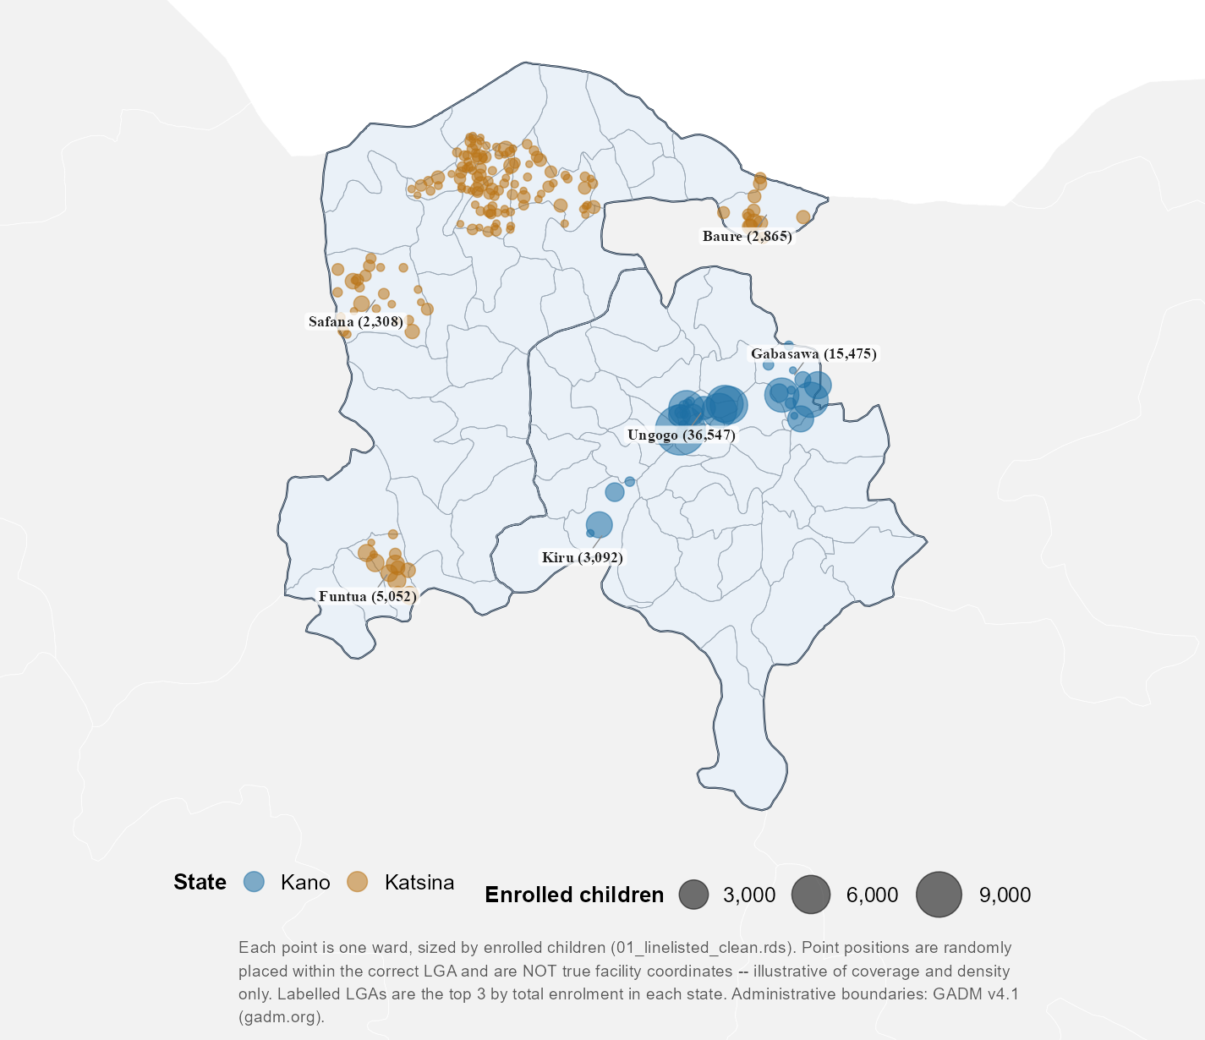
Figure 1.1. MCHTrack’s ward-level footprint across Kano and Katsina
Ward-level map of MCHTrack’s footprint across Kano and Katsina, each point one ward sized by enrolled children. Point positions are randomised within the correct LGA, illustrative of coverage and density only. Labelled LGAs are the top three by enrolment in each state.
The Sahel, the semi-arid belt stretching from Senegal to Sudan and encompassing Nigeria’s far north, faces compounding pressures. Sabahelzain et al. (2025) synthesise conflict and coverage data across five Sahel countries between 2019 and 2023: drought, desertification and food insecurity on one side, a wave of military takeovers across Burkina Faso, Mali, Chad, Niger and Sudan since 2021 on the other. By 2023, Sudan’s ZD rate reached 43 per cent, Mali’s 22 per cent and Chad’s 16 per cent, likely underestimates given conflict-affected areas surveys struggle to reach and outdated census denominators. A highly mobile population compounds this, since routine data systems struggle to track people who rarely stay in one place long enough to be counted.
Distrust in immunisation programmes has its own history in this region. The 2003–04 boycott of the polio vaccine across northern Nigeria grew out of religious misconceptions about vaccine safety, anti-colonial sentiment toward a foreign-led intervention, and local leaders using it as a political tool against federal authority; confirmed cases rose from 202 in 2002 to 1,143 by 2006, spreading to roughly a dozen other countries before transmission was controlled (Jegede, 2007; Ghinai et al., 2013). Sabahelzain et al. (2025) note renewed armed-group activity in the same corridor, though their data cannot establish whether this reflects a resurgence of 2003-era distrust or simply conflict making communities harder to reach; the two are not mutually exclusive, since insecurity can deepen suspicion of health workers while also blocking physical access (MacDonald and SAGE Working Group on Vaccine Hesitancy, 2015). Access here is inconsistent rather than closed: the same insecure areas that sometimes see health workers kidnapped still admit vaccinators, a more mixed pattern than the more uniformly restrictive access reported in Pakistan and Afghanistan. This thesis returns to that distinction when interpreting its ZD data.

B. Predictors of zero-dose status and tracing effectiveness
Distance to a health facility is among the most consistently identified predictors of ZD status in sub-Saharan Africa, though the mechanism linking distance to non-vaccination remains a matter of ongoing conceptual work. Guagliardo (2004) frames spatial accessibility not as a single measure but as an interaction between where services are located, how populations are distributed, and what transport options connect the two, a distinction that matters for how distance is operationalised below.
Two studies illustrate the same predictor through different methods. Farrenkopf et al. (2023), analysing household survey data across 82 low- and middle-income countries, identify distance to a health facility as among the strongest ZD predictors, alongside maternal education, household wealth and birth order, none of which MCHTrack collects, so this review focuses on distance, the one predictor this thesis’s data can test. Joseph et al. (2020) approach the same relationship geographically: modelling travel time to the nearest immunising facility in Kenya, they find under a third of the population within an hour’s walk under a walking-only scenario, a burden that materially reduces the likelihood of full immunisation. A household survey and a geographic accessibility model converge on distance despite measuring it differently, a stronger basis for treating it as a genuine driver than either study offers alone, though neither captures how that burden changes over time. Blanford et al. (2012) add this seasonal dimension in Niger, modelling wet- and dry-season cost-distance separately and finding the wet season substantially lengthens travel times in riverine and low-lying areas, a dated estimate whose magnitude should not be assumed to transfer to Kano and Katsina.
Defaulter tracing and recovery, the second pillar of this thesis, has received comparatively less direct attention in the African literature. A defaulter is a child who started but did not complete their scheduled vaccination course; tracing is following up to complete it. The most directly comparable evidence comes from outside the continent: using a provincial electronic immunisation registry covering 8.8 million children in Sindh, Pakistan, Miraj et al. (2024) find over ninety per cent of children defaulted on at least one scheduled vaccine, though most were eventually recovered through supplementary outreach. Children in remote rural areas and those born at home, despite higher default rates, were less likely to remain permanently uncovered than children enrolled through fixed facilities, which the authors attribute to outreach disproportionately reaching the most marginalised groups, though a rural or home-born child recorded as recovered might equally have been vaccinated elsewhere without the registry linking back to the original record. Miraj et al. (2024) cannot rule this out, and neither can this thesis’s tracing data, a caveat worth carrying forward. This reversal of an otherwise intuitive deprivation-recovery relationship is a useful precedent, though Sindh’s infrastructure is not comparable to Kano and Katsina’s.
These predictors sit within a wider landscape of interventions attempting to close the zero-dose gap, dividing into vertical, campaign-style approaches, intensive, time-limited and disease-specific, and horizontal ones integrated into routine primary care (Mills, 2005). Where an intervention sits on this spectrum shapes what data it generates: campaign-style interventions produce coverage snapshots, while a horizontal, technology-enabled programme like MCHTrack produces the continuous, individual-level tracking the predictor literature would need to test its claims against real programme data rather than survey report.

C. Weather and health-seeking behaviour
Section I.A described drought, food insecurity and a mobile population as part of the wider pressure Sahelian households face; Section I.B described distance as the predictor best supported by literature, and tracing as a mechanism whose reported effectiveness may not match reality. Weather sits outside both: whether it independently changes immunisation-seeking behaviour is a separate, testable question this section reviews.
Two studies test the weather-immunisation link directly, using different data. Nagata et al. (2021) linked Demographic and Health Survey data from 137,379 children across twenty-two sub-Saharan African countries to thirty-year rainfall records, defining drought as annual precipitation below the fifteenth historical percentile; drought at birth was associated with small but consistent reductions in BCG, DPT and polio vaccination, strongest closest in time to the drought. The authors note no empirical research had rigorously examined this relationship before their study; the only prior evidence was anecdotal, a measles vaccination rate of 47 per cent recorded during the 1983–85 drought in Timbuktu, Mali (Nagata et al., 2021, citing Carnell and Guyon, 1990), a coincidence in time rather than a tested causal link.
Using over 132 million immunisation records from Sindh’s provincial electronic registry, Siddiqi et al. (2025) find heat wave days reduced immunisation delivery in Pakistan: enhanced outreach fell most (21.2 per cent), routine outreach substantially (13.6 per cent), and fixed-site delivery was comparatively insulated (5.8 per cent), with rural divisions disproportionately affected relative to the provincial capital.
A cross-national household survey linking drought to self-reported coverage, and a high-frequency administrative registry linking heat to delivery records, converge on the same conclusion through different methods. Siddiqi et al.’s registry-based approach is the closer methodological precedent for this thesis, since it tests weather against routine delivery records rather than survey recall; no comparable study taking that approach emerged from this review’s searches, and neither study has been extended to the Sahel.
A related but mechanistically distinct literature addresses climate-induced displacement rather than weather variation. Haque, Parr and Muhidin (2019) find parents permanently displaced by flooding and riverbank erosion in Bangladesh markedly less likely to seek care outside the home for a sick child, and far less likely to use a trained provider when they did, despite their children falling ill more often, an effect the authors attribute to reduced provider access and higher transport costs rather than weather variability itself. Displacement and direct weather exposure are different mechanisms, and conflating them would overstate what either literature has shown.
A third, older literature addresses weather and scheduled healthcare attendance outside the immunisation context. Samano et al. (2021) link thirty years of heat index and precipitation data to an HIV clinic registry in Miami: extreme precipitation increased the relative risk of a missed appointment by thirteen per cent, with extreme heat showing a comparable association. This is useful chiefly as a methodological precedent, not a substantive one, since its causal mechanism runs the opposite way to this thesis’s question, heat there exacerbating chronic conditions and increasing care-seeking rather than deterring a discretionary preventive visit, and its adult, insured population bears little resemblance to the paediatric context examined here.
Taken together, these three tiers of evidence leave weather-immunisation linkages sparse, mechanistically inconsistent in what they measure, and untested in the Sahel. This thesis’s weather analysis sits closest to Siddiqi et al.’s registry-based approach, extended to a context none of the studies cover.

D. DATHARM and the MCHTrack programme
Routine immunisation in Nigeria is delivered through weekly fixed-post sessions at health facilities, plus periodic outreach in wards without one, following Federal Ministry of Health and National Primary Health Care Development Agency guidance (FMOH and NPHCDA, 2013). Which channel a caregiver can use depends on the same access barriers described earlier, and outreach is less predictable where insecurity disrupts scheduling. DATHARM, a Nigerian social-technology organisation, built its MCHTrack programme to work within this structure: finding ZD children missed by both channels, and following up those who started but did not complete their schedule.
Community health workers with mobile devices identify unvaccinated children, refer them to facilities, and trace those who default (DATHARM, 2026). Piloted in Katsina in 2019 as a maternal-health tool, MCHTrack later scaled across dozens of wards in the highest-burden LGAs (Gavi, the Vaccine Alliance, 2025), part of a broader trend of mobile registries strengthening immunisation systems in low-resource settings, though its routine, high-frequency data remain analytically unexploited in published research.
This thesis sits at the intersection of the three literatures above, though not in equal measure. Distance is a well-established ZD predictor, but measured through household survey report rather than the routine, high-frequency programme data MCHTrack generates; this thesis tests whether it holds when measured differently. Tracing recovery rates are, as Miraj et al. (2024) show, vulnerable to being read as genuine recovery when they may equally be a data artefact of what a registry can and cannot see, a question the second research question asks of its own tracing data rather than assuming the answer. Weather and immunisation-seeking have been linked directly in only two studies worldwide, neither in the Sahel and neither Nigerian, a thin evidence base the third question extends to a context it has not yet reached. MCHTrack does not close any of these three gaps outright; it offers one dataset against which to test all three at once, and to ask how far the data can be trusted to answer the question being put to it.
This thesis therefore asks three questions:
- What individual and geographic characteristics predict zero-dose status among children enrolled in MCHTrack, and how does the choice of zero-dose definition bound what those predictors can show?
- What predicts successful recovery through defaulter tracing, and to what extent do programme records support the recovery rates they report?
- Whether rainfall, heat and vegetation patterns explain any part of the variation in immunisation-seeking behaviour that the first two questions leave unexplained.
These questions share a common thread: each asks not only what the data shows, but how far it can be trusted to show it. The chapter that follows sets out the data and methods used to answer each in turn.

II. Data and Methods
Answering the first two questions requires individual-level records of enrolment, ZD status, and tracing outcomes. Answering the third requires a different kind of outcome, one that varies day to day rather than child to child, matched against weather data sourced independently of MCHTrack. This section sets out both data sources and the modelling choices built around what each can and cannot support.

A. MCHTrack data structure
Before a child’s record exists in MCHTrack, vaccination in Kano and Katsina ordinarily follows a simpler path: a caregiver becomes aware a child is due a dose through a community health worker’s (CHW) house-to-house visit, a reminder from an earlier facility encounter, or word of mouth, then travels to a facility or waits for an outreach visit. The dose, once given, is recorded on a paper card kept by the family, the primary vaccination record across most of Nigeria.
MCHTrack sits alongside this process rather than replacing it, and generates four linked datasets. CHWs carry tablets and, during house-to-house enumeration, identify children who appear to have missed scheduled doses, entering them as zero-dose in the linelisted dataset at enrolment. Linelisted records every age-eligible child a CHW enumerates, not only those flagged zero-dose, which is what makes it possible to model zero-dose status as an outcome at all: the analysis needs both zero-dose and vaccinated children to compare. A subset of flagged children are confirmed and logged in the identified zero-dose dataset, with the stated reason for non-vaccination where available. Once flagged, a referral is generated and any subsequent vaccination encounter is logged in facility visits; if a flagged child does not appear there within an expected window, a tracing attempt is logged in defaulter tracing, recording contact method, date, and outcome.
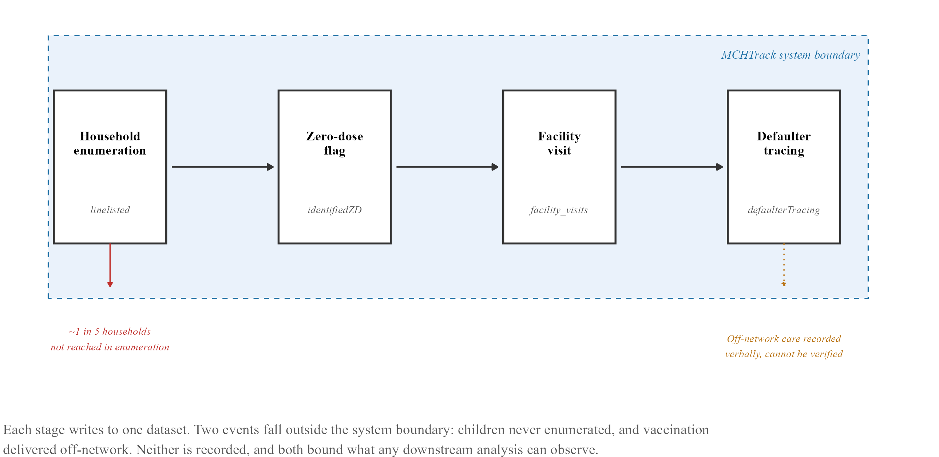
Figure 2.1. MCHTrack data pipeline and its structural blind spots
Flow diagram of a child’s path through MCHTrack: enrolment in the linelisted table, confirmation in the identified zero-dose table, any subsequent encounter in facility visits, and a tracing attempt in defaulter tracing if none appears.
Table 2.1. Baseline characteristics of enrolled children, by site
Site | N | Female (%) | Age at registration, months | Distance to facility, km | Enrolment window | Zero-dose (%)
Kano | 55,839 | 50.6% | 2.5 (0.5–9) | 0.25 (0.05–0.71) | Jul 2024–May 2026 | 8.6%
Katsina | 15,448 | 53.1% | 12 (4–32) | 0.4 (0.21–0.63) | Mar 2024–Sep 2025 | 21.7%
Overall | 71,287 | 51.1% | 4 (0.7–12) | 0.29 (0.06–0.69) | Mar 2024–May 2026 | 11.5%
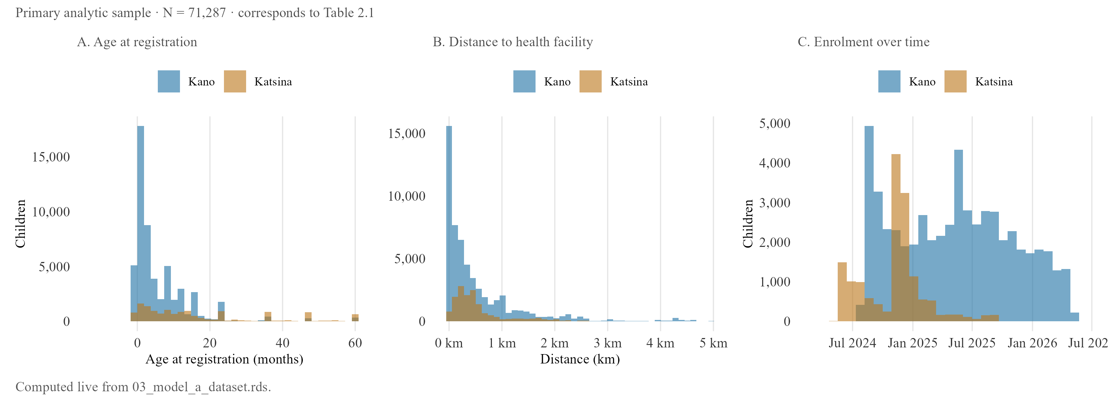
Figure 2.4. Baseline characteristics by site — age, distance, and enrolment timing
Age, distance and enrolment-timing distributions by state, corresponding to Table 2.1, computed live from 03_model_a_dataset.rds and describing the primary analytic sample.
Four properties of this system bear on what follows. First, undercounting during household enumeration is a documented problem in Nigerian immunisation planning; DATHARM’s Kano coordinator estimates roughly one in five households are missed during enumeration rounds, and no field records this gap, so every ZD count here is a count of children found, not children who exist.
Second, record reliability: Katsina’s facility visits table showed 38.9 per cent duplicate records and its linelisted table 22.1 per cent, both traced to a device handover causing records to sync more than once. Affected rows were removed at source during import, documented in the pipeline code rather than corrected silently, so Katsina results rest on a smaller, corrected sample than the raw export suggests.
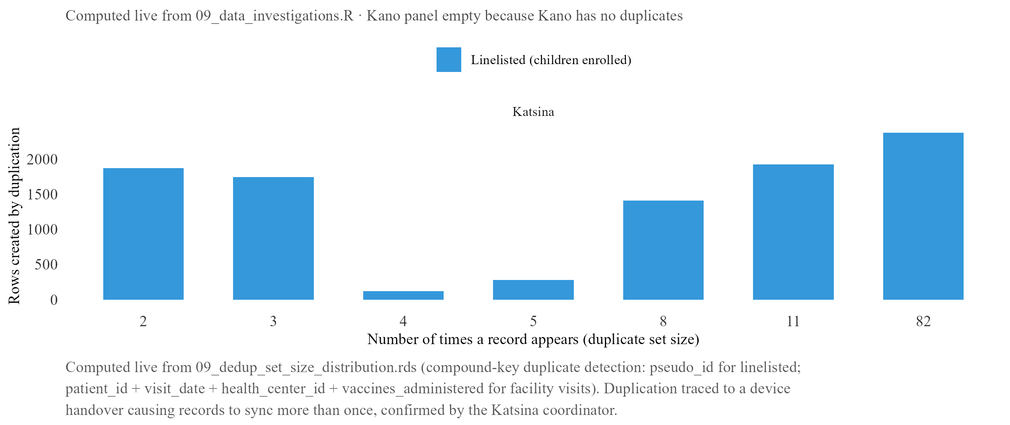
Figure 2.2. Duplicate record set sizes by state and MCHTrack table
Duplicate row counts by state and table before and after the source-level fix. Katsina’s facility visits and linelisted tables carry the bulk of the affected rows (38.9% and 22.1% respectively); Kano is comparatively unaffected.
Third, recovery: DATHARM’s protocol requires a CHW to physically check a vaccination card before recording recovery, but the tracing table records only that a card was checked, not what it showed or when, and a check simply closes the case. This gap is why a strict recovery definition and a permissive one including self-reported off-network care diverge as widely as they do (Section III).
Fourth, geography: a small number of LGAs, Rimi among them, showed signs of backfilled data entered retrospectively, so Rimi is excluded from every primary analysis, and Katsina’s data quality degrades further after September 2025, to a degree a corrected sample can no longer fully offset. The first two research questions still draw on both states, since duplication was fixed at source; the third, on weather, uses Kano alone, since a daily count outcome is far more sensitive to residual noise than a binary one.
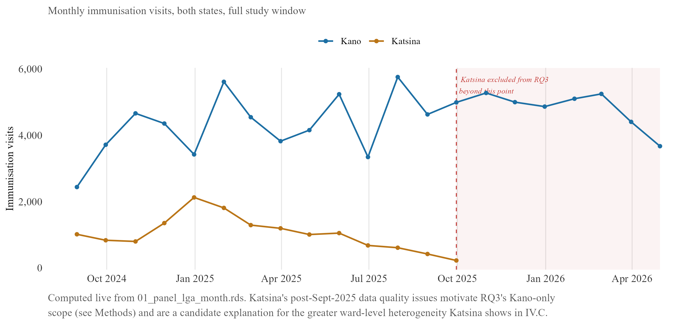
Figure 2.2b. Data reliability by state — monthly immunisation visit volume
Monthly facility visit volume, Kano vs. Katsina. Kano’s series stays broadly stable; Katsina trends down across 2025 and is excluded from the weather model beyond September 2025, the point marked on the chart.

B. Geospatial weather data
Weather data is not generated by MCHTrack and is joined to it separately, matched at LGA and day level, the finest resolution at which both sides of the join are reliably available. Daily rainfall is drawn from CHIRPS (Climate Hazards group Infrared Precipitation with Station data), maintained by the Climate Hazards Center at UC Santa Barbara, gridded at roughly 5 kilometres and available daily back to 1981 (Funk et al., 2015; World Food Programme, 2026a). Heat exposure is drawn from ERA5-HEAT, a reanalysis-derived thermal comfort product maintained by the Copernicus Climate Change Service, aggregated here to daily maximum and mean values expressed as UTCI (Universal Thermal Climate Index), a measure of perceived heat stress rather than raw air temperature (Di Napoli et al., 2021; Copernicus Climate Change Service, 2026). A vegetation greenness index, NDVI (Normalised Difference Vegetation Index), derived from dekadal MODIS satellite composites, is included as a proxy for agricultural conditions and indirect economic pressure on households (World Food Programme, 2026b).
All three were selected against the same criteria: daily or near-daily resolution, full coverage of Kano and Katsina across the study period, and a record of prior use in comparable health research. CHIRPS and ERA5-derived heat indices meet this bar most directly, both used in the two studies identified as the closest precedent (Section I.C). NDVI is more exploratory, included on the strength of an established link between vegetation conditions and household agricultural income in Sahelian settings rather than any direct precedent in the immunisation literature.

C. Model specification and justification
The data limitations above bear directly on how each research question is answered. This section sets out two model types: a shared logistic regression framework answering the first two questions, and a separate count-based model answering the third.

i. The zero-dose and recovery models
The first question, what predicts zero-dose status, and the second, what predicts successful recovery through defaulter tracing, are both answered using logistic regression with ward-level fixed effects. The model answering the first is called the zero-dose model and the model answering the second the recovery model throughout this thesis.
Two distinctions recur throughout the results that follow and are defined here rather than left implicit. Zero-dose status is measured two ways: the primary definition uses MCHTrack’s operational flag, a child missing the first scheduled dose specifically; a stricter definition requires no vaccine contact of any kind recorded in the system. Recovery, similarly, is measured under a strict definition, a confirmed in-network vaccination record, and a permissive definition that also counts self-reported off-network care confirmed only by an unverified card check. Tracing method, or channel, refers to how a defaulter-tracing attempt was made: SMS or phone contact, or an in-person home visit.
Both outcomes are binary, so logistic regression is used rather than ordinary linear regression, which can produce fitted probabilities below zero or above one, estimated using feglm() in the fixest package (Bergé, 2018), which absorbs fixed effects computationally, a practical necessity given the number of wards involved.
Nigeria’s administrative structure runs from federal level through 36 states, LGAs, and wards, the smallest unit at which MCHTrack records a child’s location; Kano State alone contains 44 LGAs and several hundred wards, finer than most household surveys can support. Both models apply fixed effects at this ward level, since wards differ systematically in baseline zero-dose rates for reasons unrelated to any individual predictor, including how thoroughly each has been enumerated; without accounting for this, a model risks crediting ward-level differences to distance, the likeliest correlated predictor given how unevenly facilities are distributed.
An earlier ward- and LGA-level rate model was abandoned once the enumeration gap (Section II.A) became clear: a rate requires a reliable denominator, which cannot be established from MCHTrack alone, whereas child-level logistic regression removes that need entirely.
Even so, the enumeration gap leaves one distinction fixed effects cannot resolve: a ward with an unusually high zero-dose count may have more unvaccinated children, or may simply have been covered by a more diligent health worker who found more of the children who were always there, and the model cannot separate these explanations from the records alone. Any ward singled out this way is a candidate for field verification, not a confirmed estimate of relative need (Section V).
The zero-dose model is specified as:
$$\text{logit}\left(P\left(\text{ZD}=1\right)\right)=β_{0}+β_{1}⋅\text{Distance}+β_{2}⋅\text{Age}+β_{3}⋅\text{Gender}+α\left(\text{ward}\right)$$
Distance and age both have strong prior support as predictors of ZD status across sub-Saharan Africa (Section I.B). Gender does not, and is included as a standard demographic control.
The recovery model is specified as:
$$\text{logit}\left(P\left(\text{Recovered}=1\right)\right)=β_{0}+β_{1}⋅\text{Method}+β_{2}⋅\text{Distance}+β_{3}⋅\text{Age}+β_{4}⋅\text{DaysSinceVisit}+α\left(\text{ward}\right)$$
Of these, only distance carries comparable prior support, and evidence on recovery specifically is thin, with Miraj et al. (2024) the only direct precedent (Section I.B). Distance and age are included because the verification gap above gives reason to expect distance might matter differently once tracing is underway: a child far from a facility may be harder to enumerate but recovery can proceed by phone or SMS without travel. Time since the last recorded visit has no precedent in this literature, one example of a wider gap in MCHTrack’s fields (Section V).

ii. The weather model
The third question, whether weather explains variation the first two models leave unexplained, requires a different outcome. ZD status changes rarely for any child; daily facility visit counts by LGA change constantly, making them the right outcome for testing whether short-term weather predicts care-seeking independent of any child’s fixed characteristics. Daily counts are heavily overdispersed (Section II.D), so the primary specification models visits as a negative binomial count rather than transforming them to a continuous scale:
$$\text{Visits}∼\text{NegBin}\left(μ\right), ln\left(μ\right)=β_{0}+β_{1}⋅\text{Rainfall}+β_{2}⋅\text{Heat}+β_{3}⋅\text{NDVI}+δ\left(\text{LGA}\right)+γ\left(\text{day-of-week}\right)+θ\left(\text{month-year}\right)$$
estimated through fenegbin() in the fixest package, with fixed effects for LGA, day of week, and month-year. A log-transformed OLS specification, ln(Visits+1), is retained throughout as a comparison, reported alongside the primary NB results in Section III.C; the plus-one term this version requires distorts the relationship most on the low-count days most exposed to the gaps described in Section II.A, one reason NB is treated as primary here.
Two robustness checks apply to both specifications: an offset term, log(enrolled_children), converting the outcome to a rate relative to each LGA’s enrolled population so more enrolled children are not mechanically credited with more visits regardless of weather; and a spline replacing the linear weather term, allowing the relationship to bend rather than assuming a straight line. Section III.C reports both checks against the primary specification.
Siddiqi et al. (2025) and Samano et al. (2021) offer the closest precedent for this approach (Section I.C). Neither registry carries the enumeration or verification gaps documented above, so a null or positive result here cannot be read on the same footing as either comparator, a point returned to in Section IV.

D. Diagnostic checks
This diagnostic applies specifically to the weather model, since it is the only one of the three with a count rather than binary outcome. Visit data shaped by discrete events such as market days and religious holiday periods typically shows variance well above the mean, a pattern the variance-to-mean ratio below confirms and one Poisson’s equal-variance assumption cannot accommodate, motivating the negative binomial specification introduced in Section II.C.ii.
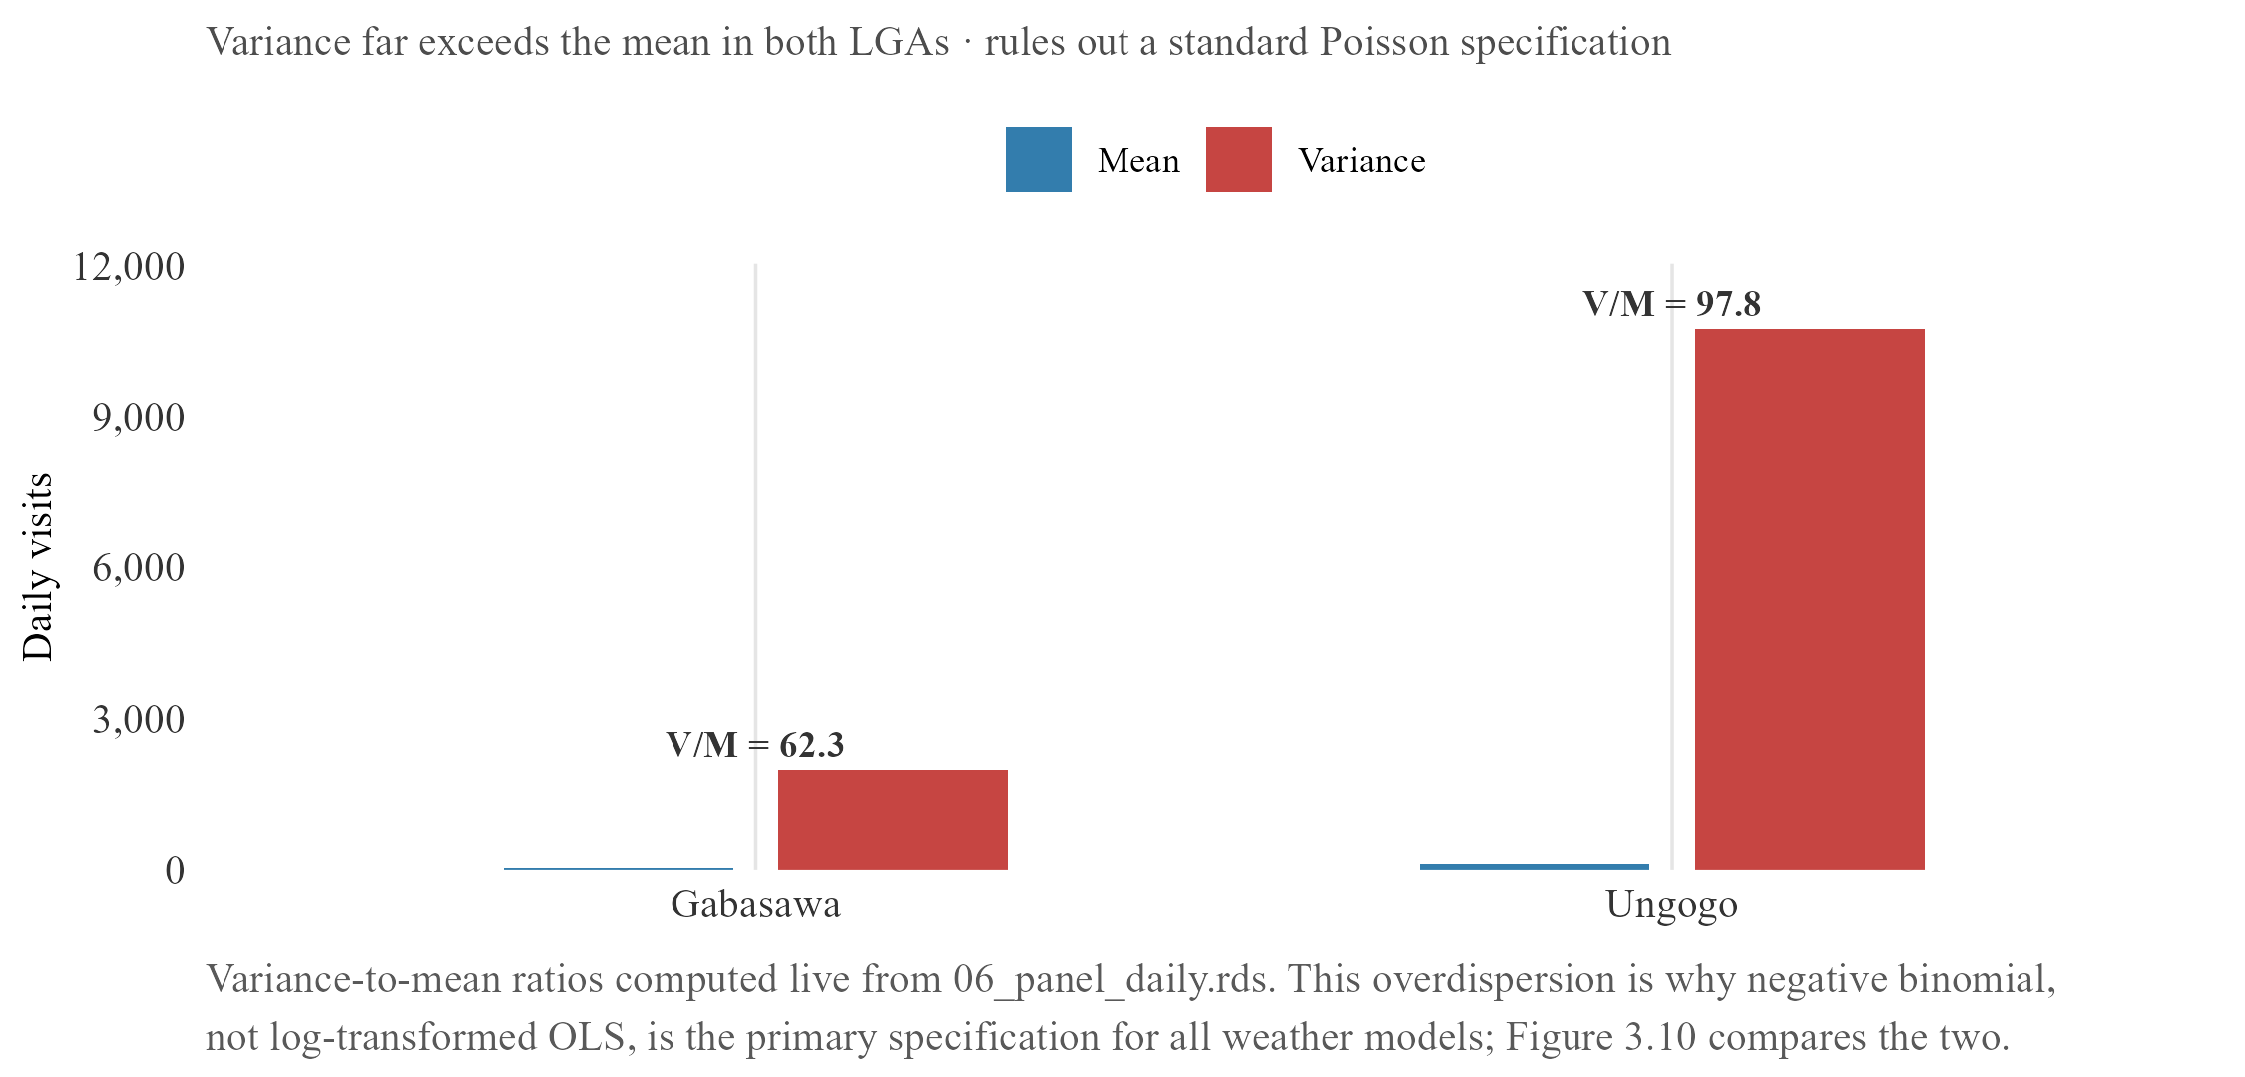
Figure 2.3. Overdispersion in daily facility visit counts
Daily visit counts are heavily overdispersed, variance well above the mean in every LGA examined. This rules out Poisson on theoretical grounds and motivates the negative binomial specification used across the weather models. The diagnostic is carried forward to Figure 3.8, where the calendar structure of quiet days is shown to be social rather than environmental.
The distributions of the main outcome and predictor variables were examined before any model was fitted, to confirm no variable behaves in a way that would undermine either specification; distributions showing no notable pattern are reported in an appendix rather than the main text.

III. Quantitative Results

0. Descriptive data overview
The primary analytic sample for the zero-dose model comprises 71,287 children across Kano and Katsina, built from 101,312 raw linelisted rows by removing 7,744 duplicate rows at import, 19,860 non-child records, 831 rows with missing or implausible distance values, and 1,590 rows in Rimi LGA for the backfill issue described in Section II.A. A further 33 rows with unattributed (“Null”) LGA values are not yet excluded from this figure; applying that step would bring the sample to approximately 71,254. The regression itself, reported below, runs on 70,477 children: a further 810 rows were excluded for singleton ward-fixed-effect groups and residual covariate missingness not itemised in the waterfall. This narrowing is not necessarily random: a household enumerated incompletely is also likely one whose distance or location data was recorded incompletely, biasing the analytic sample toward more thoroughly documented cases, a limitation carried into every zero-dose estimate below.
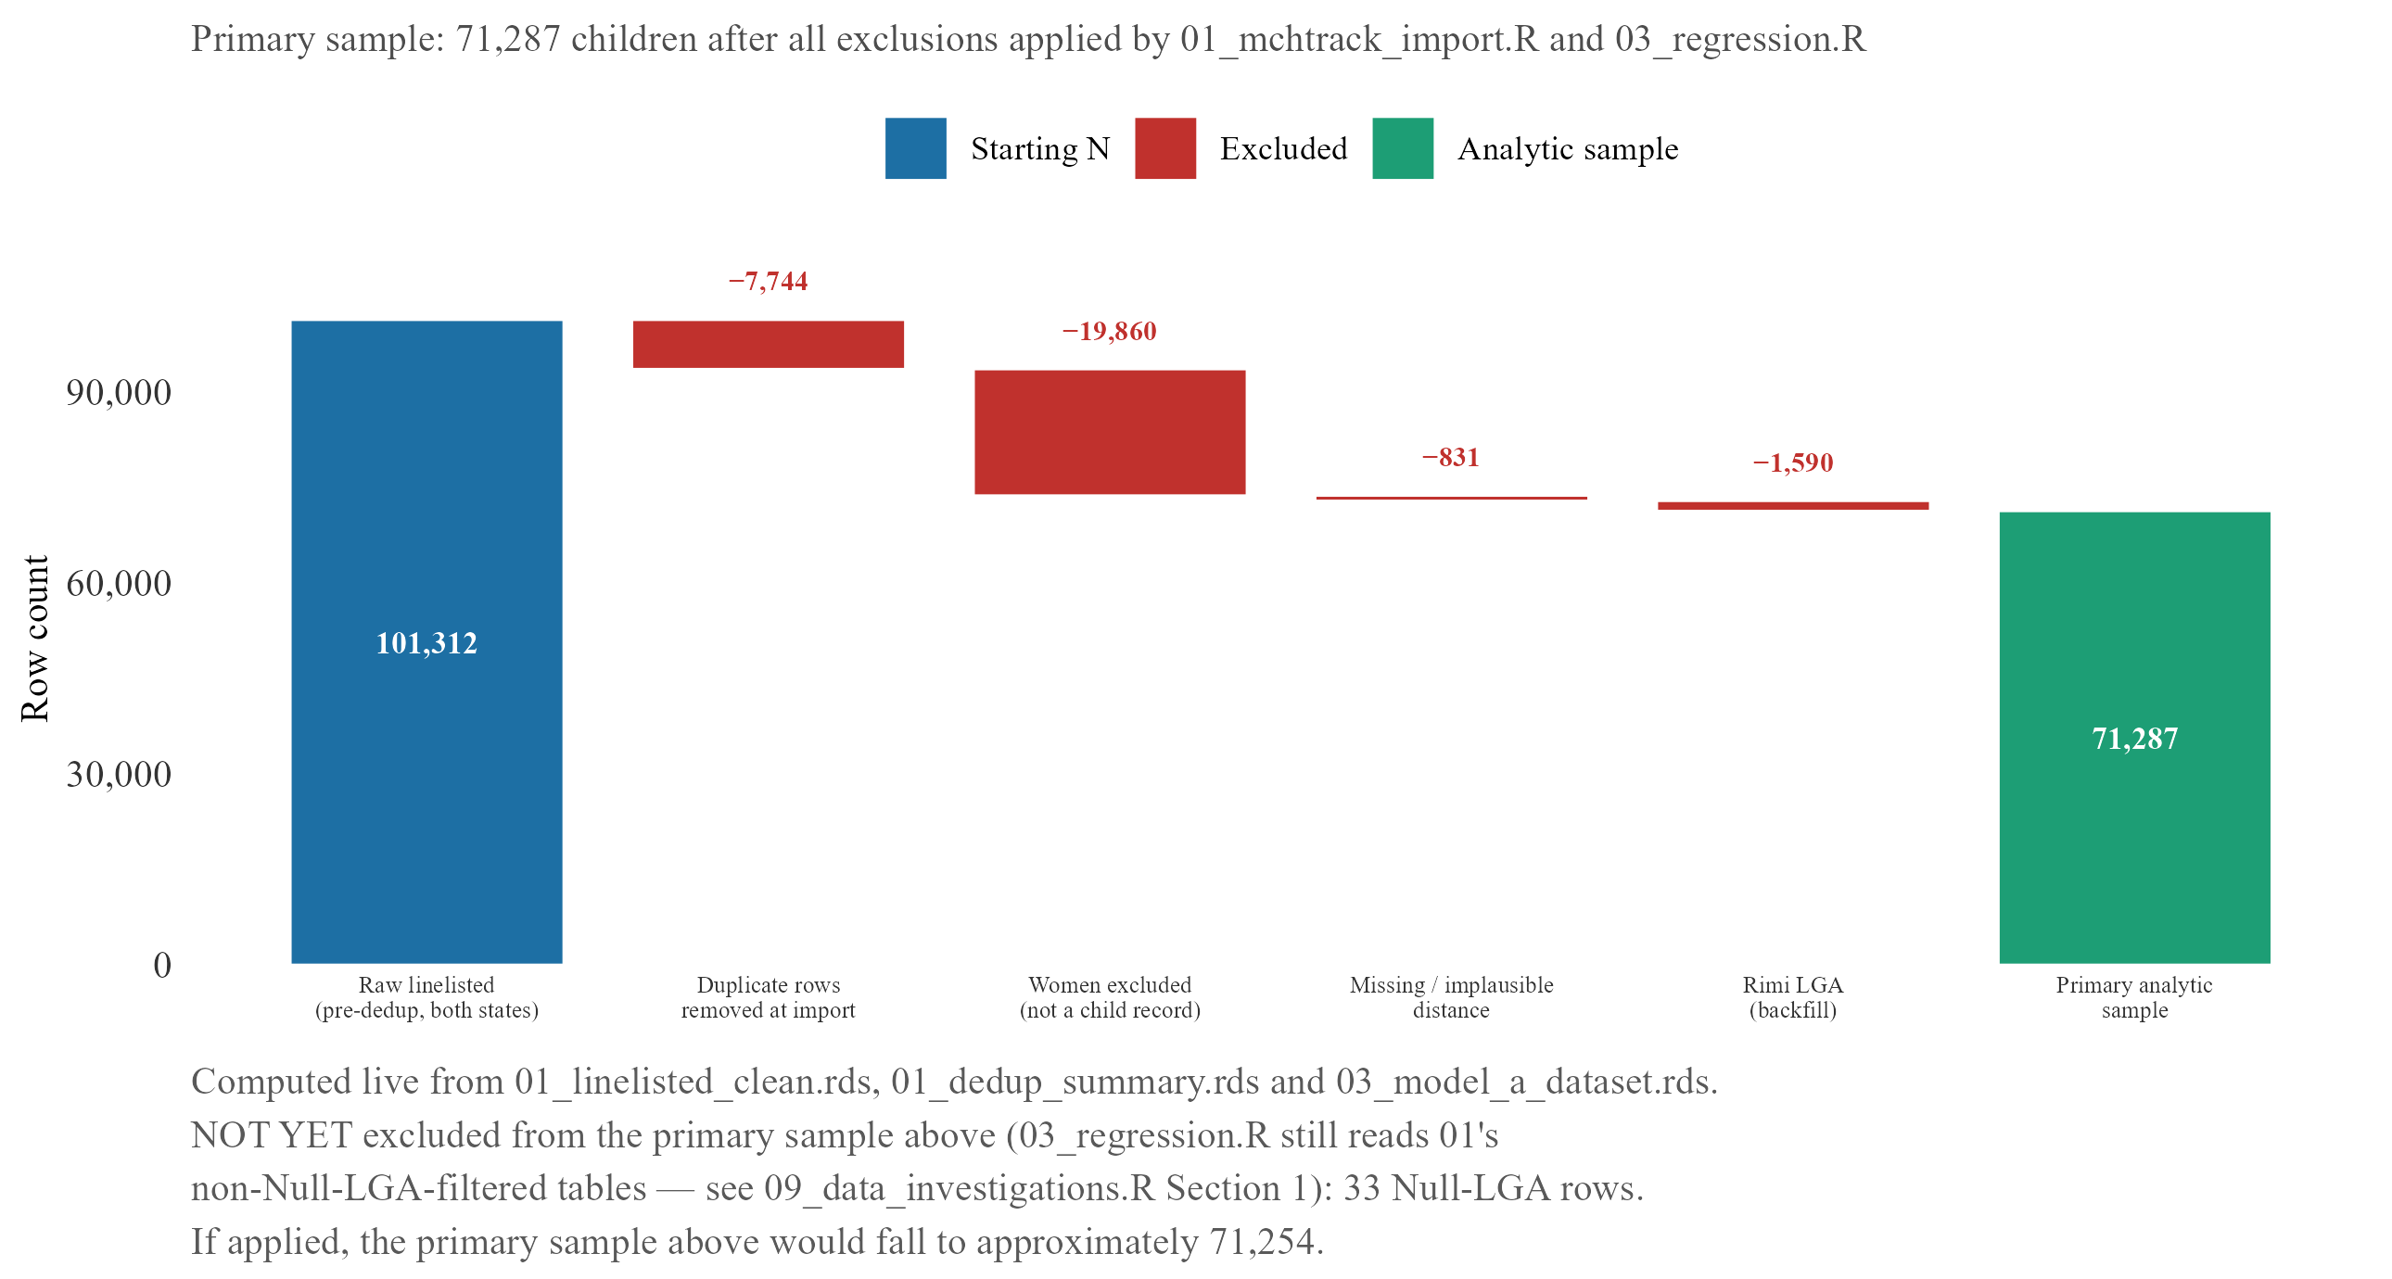
Figure 3.2. Analytic sample construction — zero-dose model
Waterfall of exclusion steps from the raw linelisted rows to the 71,287-child primary analytic sample, with the further reduction to the 70,477-child regression sample described in the text above.
Distance to the nearest health facility is heavily right-skewed across this sample; zero-dose children sit further along that tail than vaccinated children do, though the two distributions overlap substantially, and a child can live close to a facility and still be missed. The recovery model draws on a separate sample of 38,913 tracing attempts, of which 16,132 can be matched to a prior facility visit date and so carry a usable lag-time value. The weather model’s outcome, daily facility visit counts by LGA, is described separately in Section III.C, since its heavy zero-inflation and marked overdispersion motivate the modelling choice discussed in Section II.D.

A. Zero-dose model

i. Main results
Age at registration is a significant predictor of zero-dose status under both definitions, and, like distance, amplifies sharply under the strict one: each additional year is associated with roughly a 3.7 per cent increase in the odds of zero-dose status under the primary definition (95% CI on the monthly coefficient [0.001, 0.005]), consistent with children enrolled later in MCHTrack’s coverage period mechanically having had more time to fall behind schedule before anyone notices, and roughly a doubling of the odds under the strict definition (95% CI [0.045, 0.077]), an amplification of similar shape to distance’s, though this thesis’s data cannot say whether the two share a common mechanism. The pattern is visible in concrete terms too: zero-dose children are typically registered at a median age of around ten and a half months, against under a month for children with five or more recorded doses. Gender shows no significant effect in any specification, contrasting with parts of the DHS-based literature reporting gender effects in northern Nigeria, and may reflect how children come to be enrolled in MCHTrack rather than the absence of a true effect.
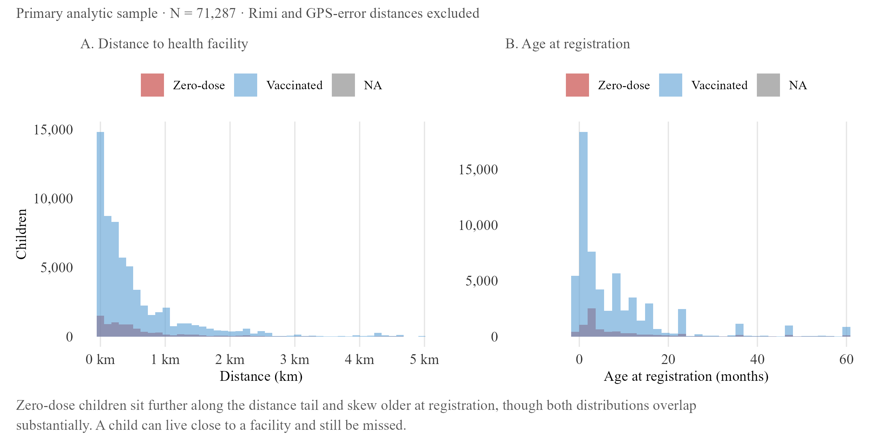
Figure 3.1. Predictor distributions by zero-dose status
Panel A: median distance to nearest facility by recorded dose count. Zero-dose children sit at roughly 0.5 km, more than double the 0.15–0.2 km typical of children with one or more doses. Panel B: median age at registration by dose count, falling from around 10.5 months at zero doses to under a month by five to six or more doses.
Distance to the nearest health facility is the central result of this model, and its size depends entirely on how zero-dose is defined: under the primary definition, distance is associated with only a small, non-significant increase in the odds of zero-dose status, roughly 4 per cent per additional kilometre (95% CI [−0.001, 0.085], crossing zero); under the strict definition, the same one-kilometre increase is associated with an 87 per cent increase (95% CI [0.237, 1.017]), roughly fifteen times the primary specification’s coefficient and clearly significant. This gap is itself informative rather than a modelling inconvenience: a child who has received some vaccine but then fallen off the schedule has already demonstrated some capacity to reach a facility at least once, so whatever drives their zero-dose status under the primary definition is more likely timing, a missed appointment, a stockout, a family’s shifting priorities, than distance itself, while a child with no recorded contact at all is a cleaner test of pure physical access, and it is here that distance shows its strongest effect. The primary and strict definitions are best understood as describing two different populations rather than two estimates of the same thing, speaking directly to this thesis’s first research question: the choice of zero-dose definition does not just change a number, it changes which predictors the data can reveal. A state-by-distance interaction term was also tested and found not significant.
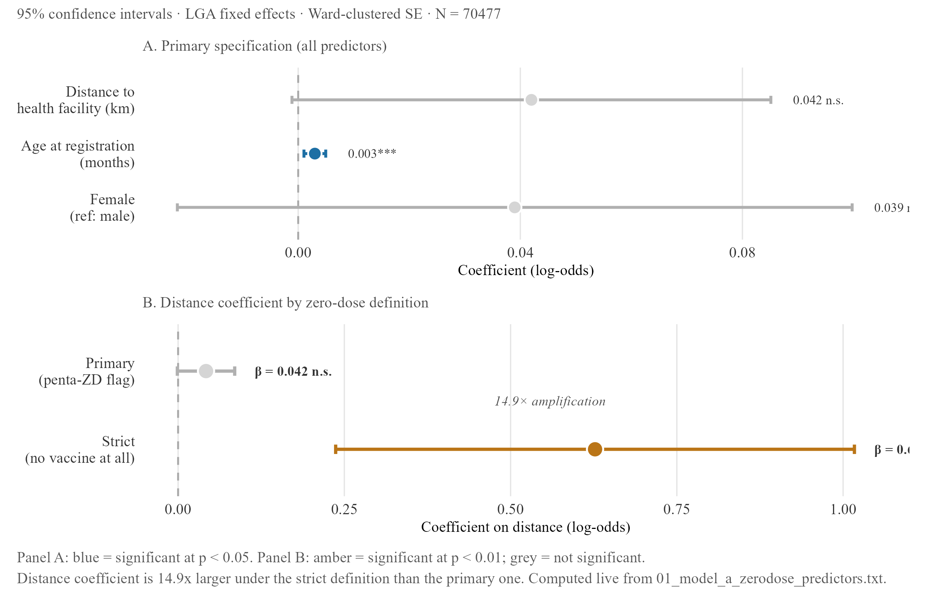
Figure 3.3. Zero-dose model — primary specification and definitional amplification
Log-odds coefficients with 95% CIs for distance, age and gender under both definitions. The distance bar’s amplification between panels is the same fifteen-fold jump reported in the text; gender stays small and non-significant throughout.
Table 3.1a. Zero-dose model — regression summary
 | Primary definition | Strict definition
Distance to health facility (km) | 0.042 [-0.001, 0.085] | 0.627*** [0.237, 1.017]
Age at registration (months) | 0.003*** [0.001, 0.005] | 0.061*** [0.045, 0.077]
Female (ref: male) | 0.039 [-0.022, 0.1] | 0.040 [-0.036, 0.116]
N | 70477 | 70477
R² | 0.068 | 0.220
Estimates on the log-odds scale; 95% CIs in brackets; ward-clustered SE (definitions in Section II.C.i). Distance is not significant under the primary definition but becomes strongly significant under the strict definition. ** p < 0.05 *** p < 0.01

ii. Ward-level residuals: a limit, not a targeting signal
The regression’s ward-level fixed effects can also be examined directly, as residuals showing which wards have more or fewer zero-dose children than the model predicts once distance, age, and gender are accounted for. In Katsina, this exercise identifies several wards with markedly higher residuals than anywhere in Kano: Wagini, in Safana LGA, sits 59.5 percentage points above prediction (n = 37), Babban Duhu B, also in Safana, 51.5 points above (n = 80), and a further cluster across Mani and Funtua LGAs each exceeding 20 points, including Kurfeji (Mani, +46.8pp, n = 42), Makera (Funtua, +37.5pp, n = 351), Duwan Makau (Mani, +27.9pp, n = 41) and Bakiyawa (Batagarawa, +25.3pp, n = 378). In Kano, by contrast, the largest residual found, Maraku ward in Gabasawa LGA, reaches only 13.2 percentage points above prediction (n = 89), and the overall spread across Kano’s wards is markedly flatter.
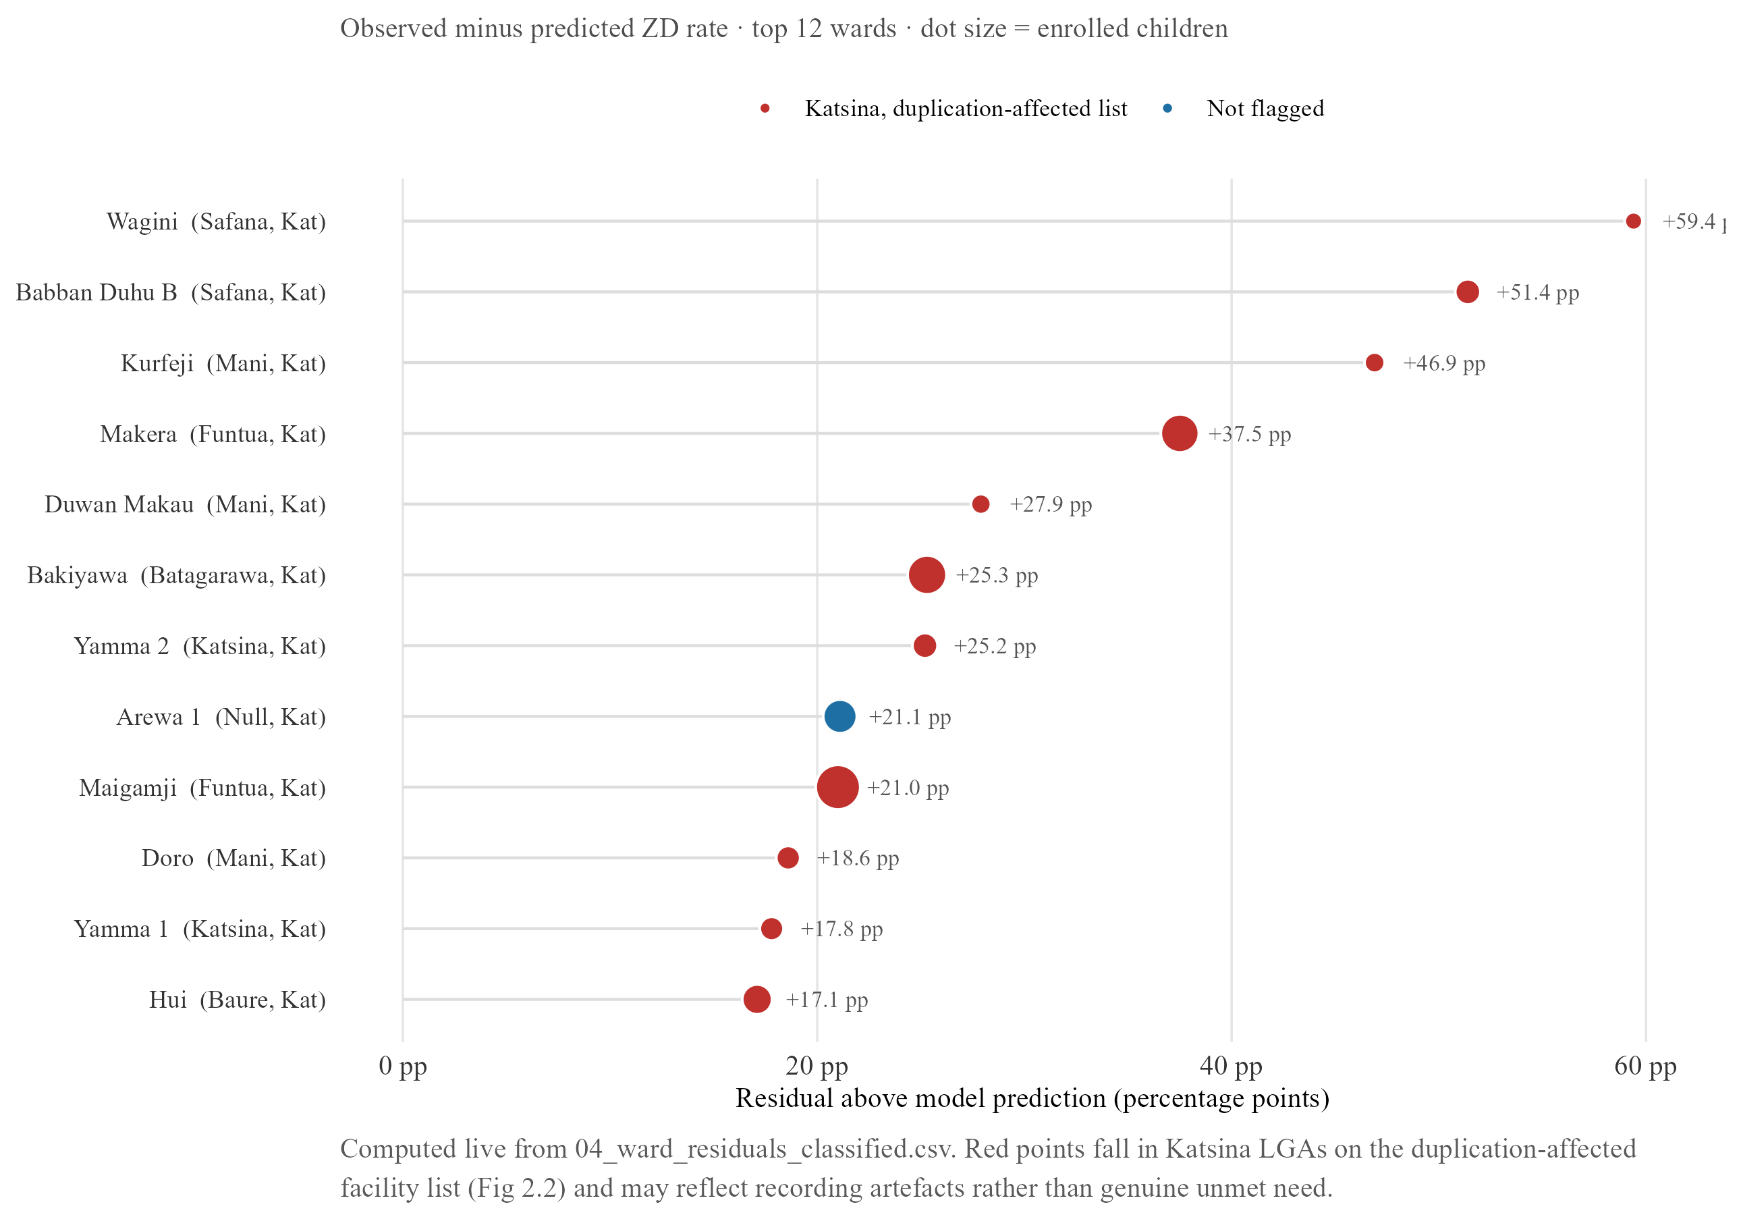
Figure 3.4. Ward-level residuals from the zero-dose model
Lollipop chart of ward-level residuals, ordered by magnitude. Katsina’s tail is long and dominated by Safana LGA wards; Kano’s residuals cluster tightly near zero, with Maraku (Gabasawa) as its single largest outlier.
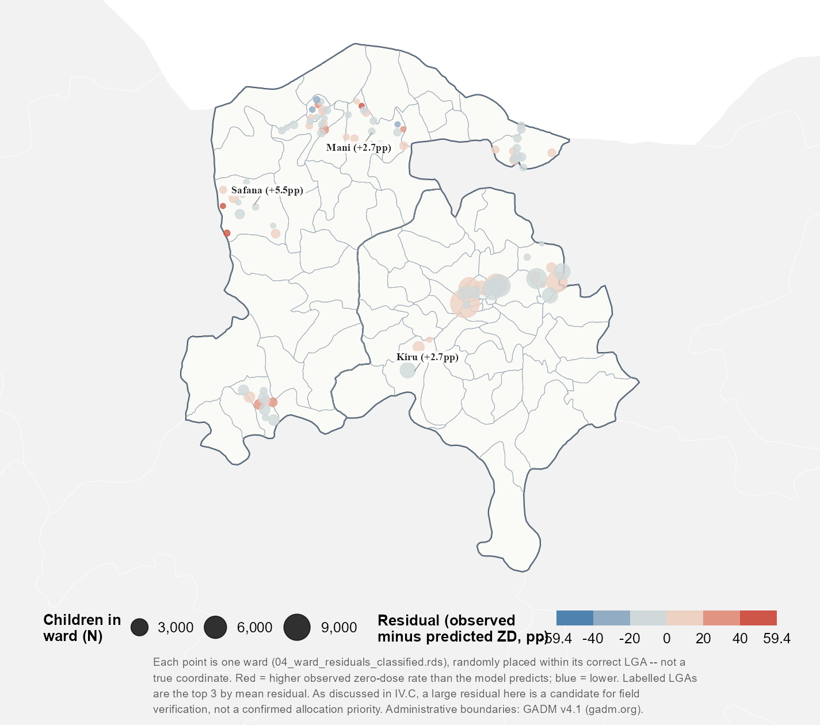
Figure 3.4b. Ward-level zero-dose model residuals, mapped
The same residuals mapped by ward rather than ranked in a list. Katsina’s largest residuals cluster within Safana, Mani, Funtua and Batagarawa LGAs rather than scattering evenly across the state; Kano’s residuals stay close to zero everywhere on the map.
This contrast should not be read as evidence that Katsina has more genuine pockets of unmet need than Kano. Katsina is also the state where a device handover produced duplicate records in 38.9 per cent of facility visits (Section II.A), and a ward whose visit records were inflated or distorted by this duplication could show an artificially large residual having nothing to do with true underlying need. Kano’s flatter spread, meanwhile, may simply reflect that the state’s more even data quality leaves less room for any single ward to stand out, rather than indicating its zero-dose burden is genuinely more uniform. Taken together, the two states illustrate a limit of ward-level analysis built on routine programme data rather than a usable targeting map: the state with the most striking residuals is also the state whose records are least trustworthy at this resolution, and the state whose records are most trustworthy shows too little variation to act on with confidence. Any ward flagged this way is better treated as a candidate for field verification than a confirmed allocation priority (Section V).

B. Recovery model

i. Main results
SMS or phone contact, relative to home visits, is associated with higher odds of confirmed recovery across every specification: roughly a 56 per cent increase in the lag-time subset (β = 0.444, p < 0.01) and a 55 per cent increase in the full sample (β = 0.436, p < 0.001). This is reported as an association, not a claim that SMS is the more effective channel: the tracing table has no field recording whether an attempt was a first-line contact or an escalation after an earlier one failed, and DATHARM allows multiple attempts per child. If home visits are disproportionately reserved for cases that already failed to respond to SMS, as fieldwork suggests may happen, home-visit rows would systematically represent harder-to-reach cases, and this coefficient would partly reflect that sequencing rather than either channel’s intrinsic effectiveness; ranking attempts chronologically by tracing date is a further research direction (Section V). Distance shows no significant effect in either specification (95% CIs of [−0.355, 0.147] and [−0.171, 0.069], both crossing zero); age at tracing reaches significance in the full sample, though negligibly small, and loses significance in the lag-time subset once days-since-visit is added, consistent with the two variables capturing overlapping information. Distance’s near-total absence is a genuine departure from the zero-dose model, where it was the dominant predictor under the strict definition: a recovery attempt by phone or SMS does not require the physical travel that enrolment does.
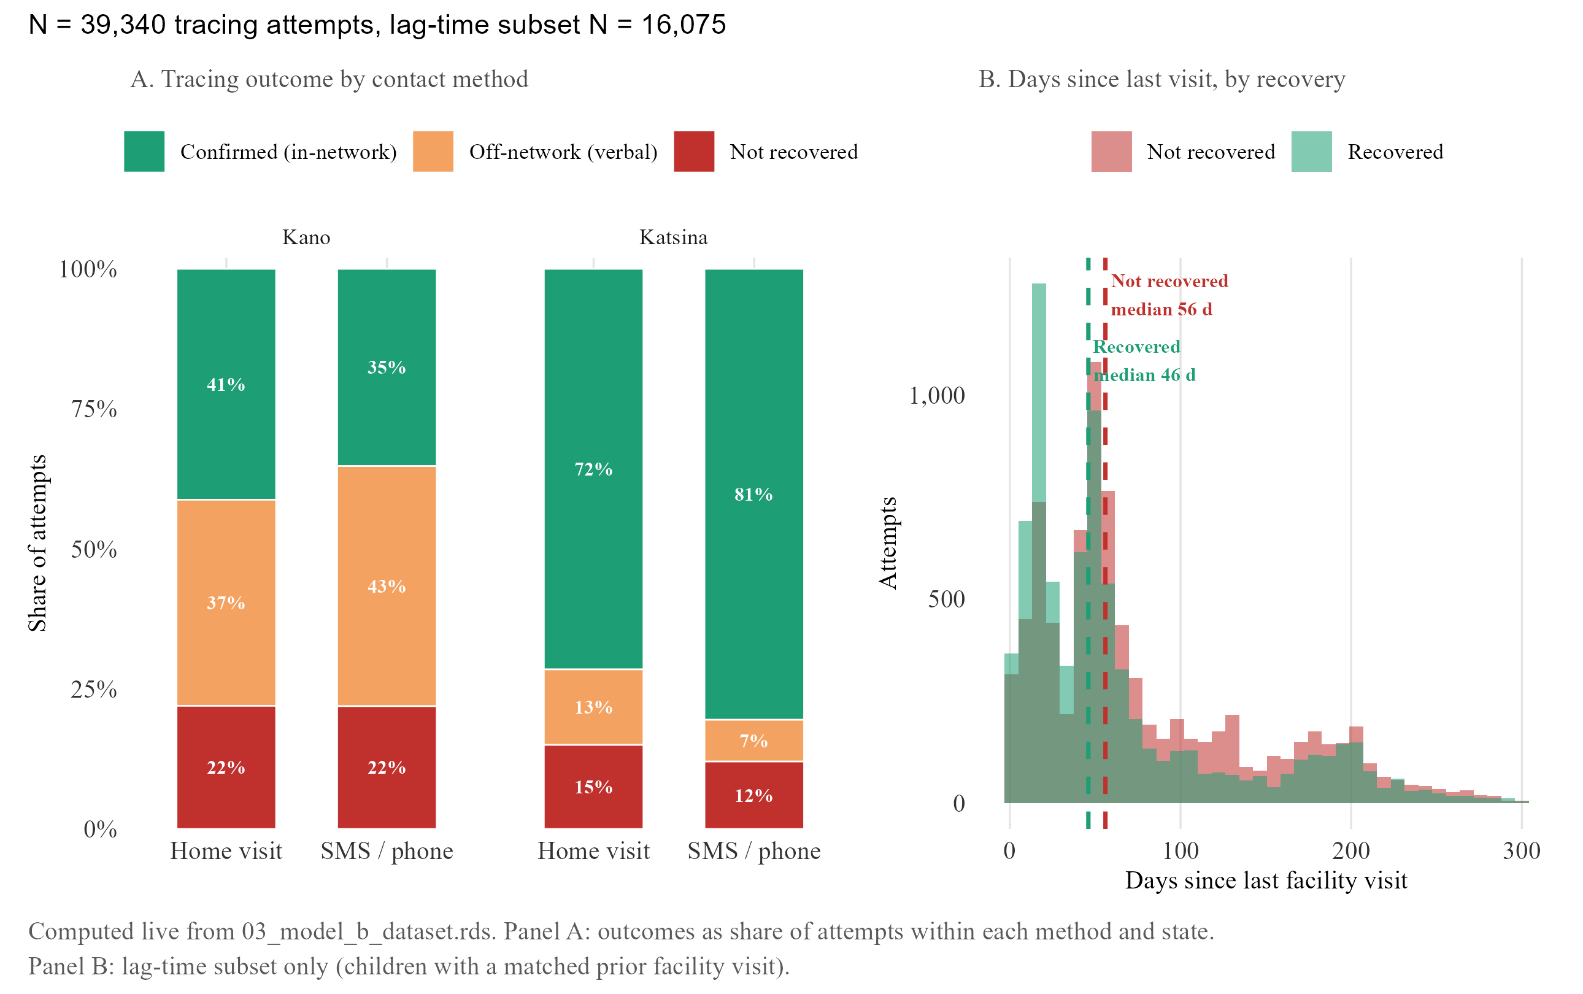
Figure 3.5. Tracing outcomes and timing
Panel A: recovery outcome by contact method, showing the state-level reversal (SMS ahead in Katsina, home visits ahead in Kano). Panel B: days between last facility visit and tracing contact, recovered vs. unrecovered cases.
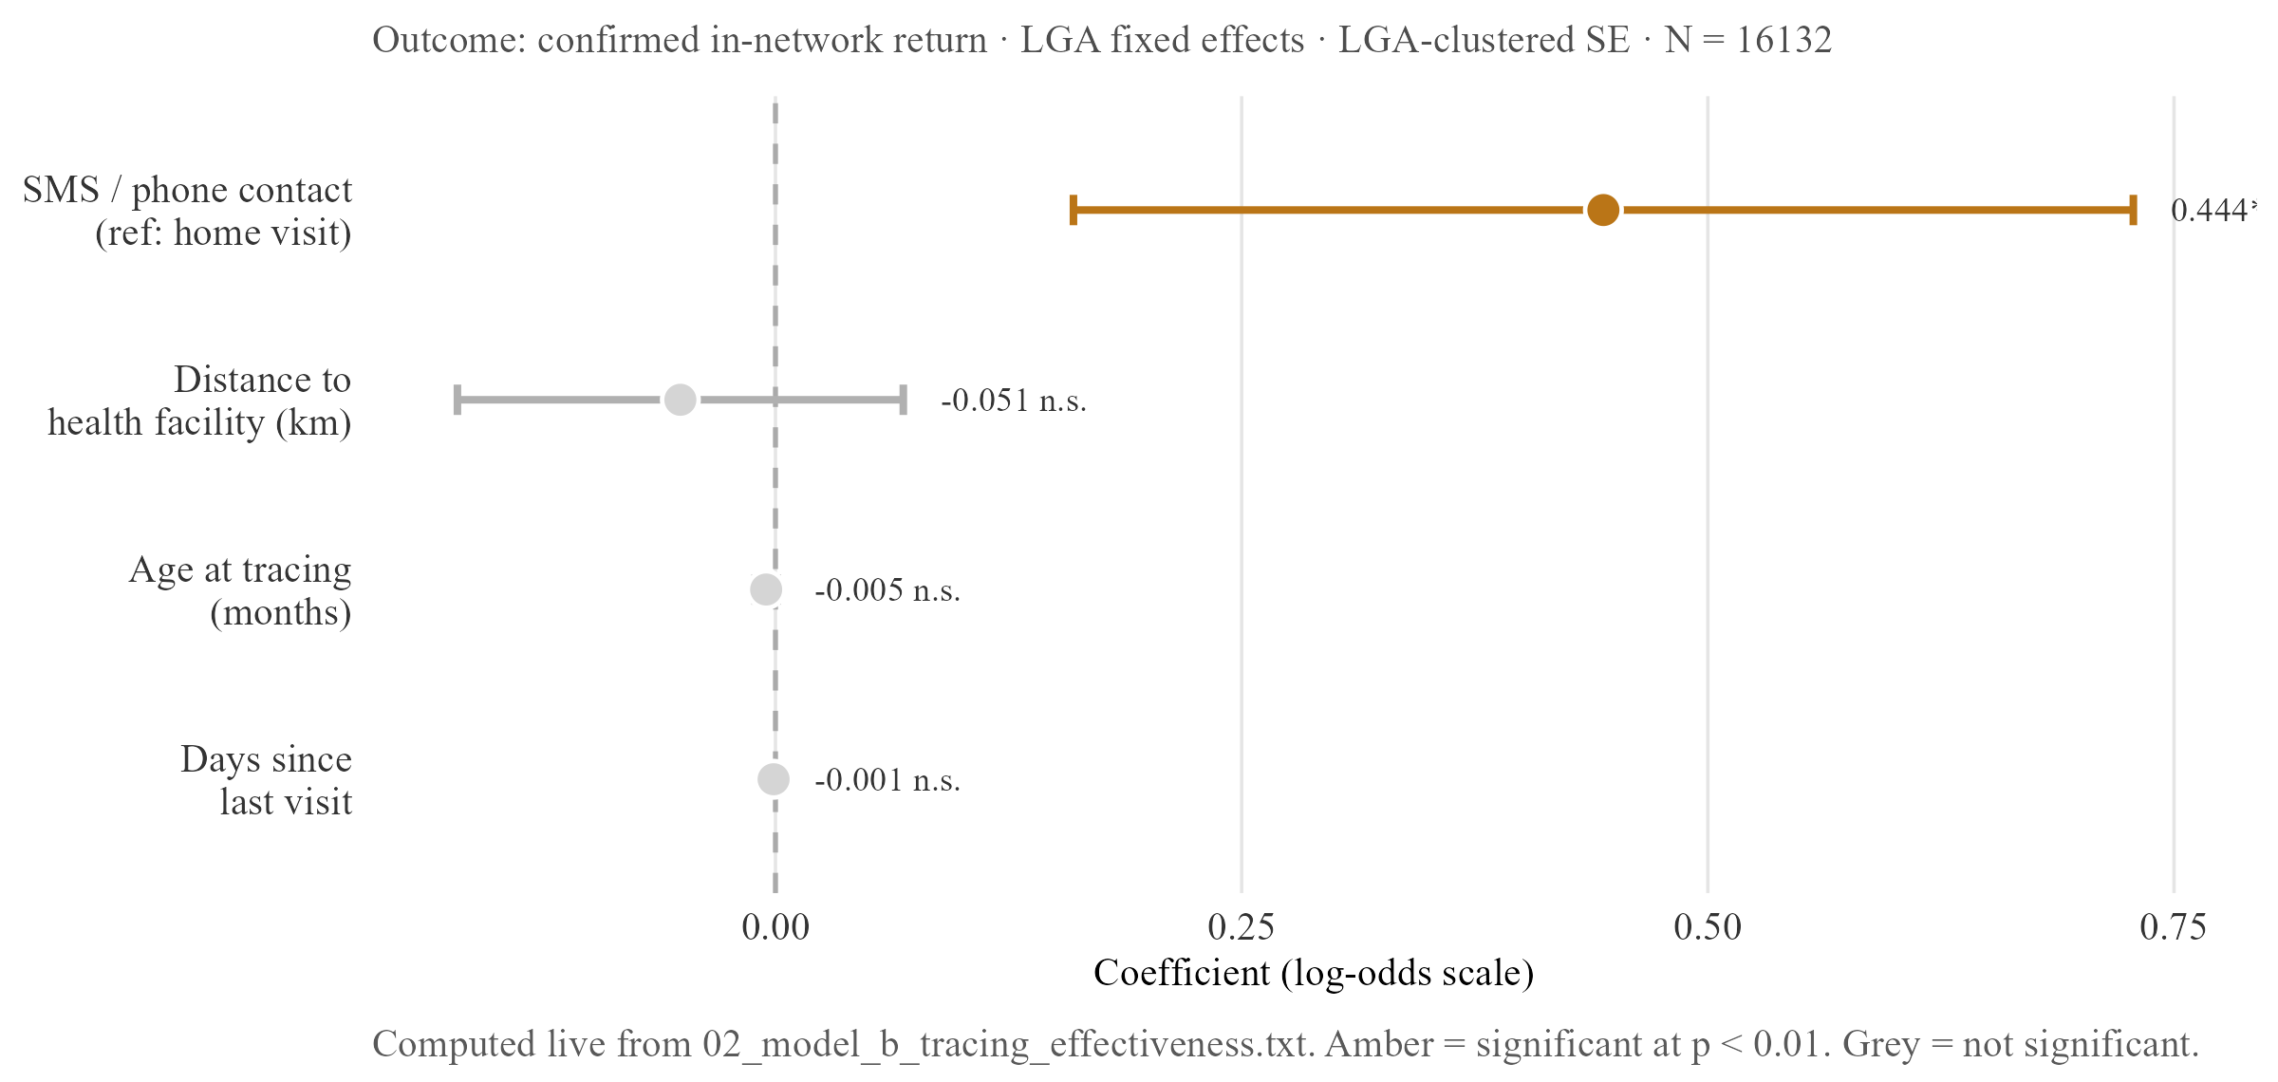
Figure 3.6. Recovery model — coefficient plot
Log-odds coefficients with 95% CIs, full sample and lag-time subset. SMS/phone contact is the only bar clearing significance in either specification; distance, age at tracing and days-since-visit all straddle zero or are negligibly small.
Table 3.1b. Recovery model — regression summary
 | Full sample | Lag-time subset
SMS / phone contact (ref: home visit) | 0.436*** [0.183, 0.689] | 0.444*** [0.16, 0.728]
Distance to health facility (km) | -0.104 [-0.355, 0.147] | -0.051 [-0.171, 0.069]
Age at tracing (months) | -0.001*** [-0.001, -0.001] | -0.005 [-0.011, 0.001]
Days since last facility visit | n/a — not in full-sample spec | -0.001 [-0.003, 0.001]
N | 38913 | 16132
R² | 0.110 | 0.117
Estimates on the log-odds scale; 95% CIs in brackets; LGA-clustered SE. SMS/phone contact is the only consistently significant predictor of confirmed recovery; distance is null in both specifications. ** p < 0.05 *** p < 0.01
The full tracing dataset comprises 38,913 attempts. A lag-time value, days since the child’s last recorded visit, can only be constructed where a prior visit exists in the facility visits table, which holds for 16,132 of these, fewer than half, two subsets unlikely to be equivalent: children retained in the lag-time subset have, by construction, at least one prior recorded visit, meaning they were already somewhat engaged with the formal system before defaulting, a probably more reachable population than the full traced group.
Recovered children also resolve faster than the tracing dataset as a whole: the median gap between last recorded visit and a successful contact is 46 days among recovered cases against 56 among the full traced group, consistent with contact working best while a lead is still fresh, whichever channel is used. The state-level picture complicates a simple reading of the pooled coefficient above: in Katsina, SMS-traced cases recover at 77.3 per cent against 68.7 per cent for home visits, while in Kano the pattern reverses (40.1 per cent vs 35.2 per cent). DATHARM’s Kano coordinator described this as a deliberate state-level operational choice, a separate explanation from the attempt-sequencing question above; both may be operating at once, and neither is resolvable from the pooled estimate. State-stratified coefficients and per-method attempt counts are a concrete next step (Section V).

ii. Strict versus reported recovery
The recovery rate reported by the programme depends heavily on how recovery is defined (Section II.C.i): the pooled rate is 42.6 per cent under the strict definition and rises to 77.2 per cent under the permissive one, which also counts self-reported off-network care confirmed only by a card check with no detail of what the card showed.
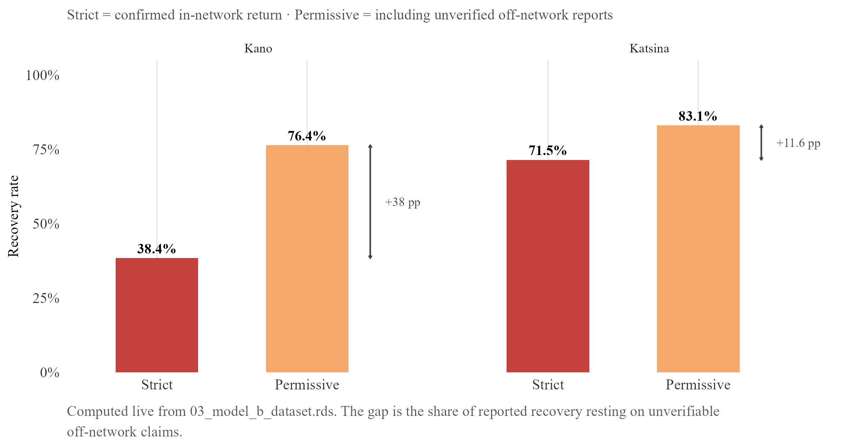
Figure 3.7. Strict versus permissive recovery rate by state
Strict vs. permissive recovery rate, split by state: under the permissive definition a programme would claim roughly double what a strict, verifiable standard supports, and the overstatement varies sharply by state.
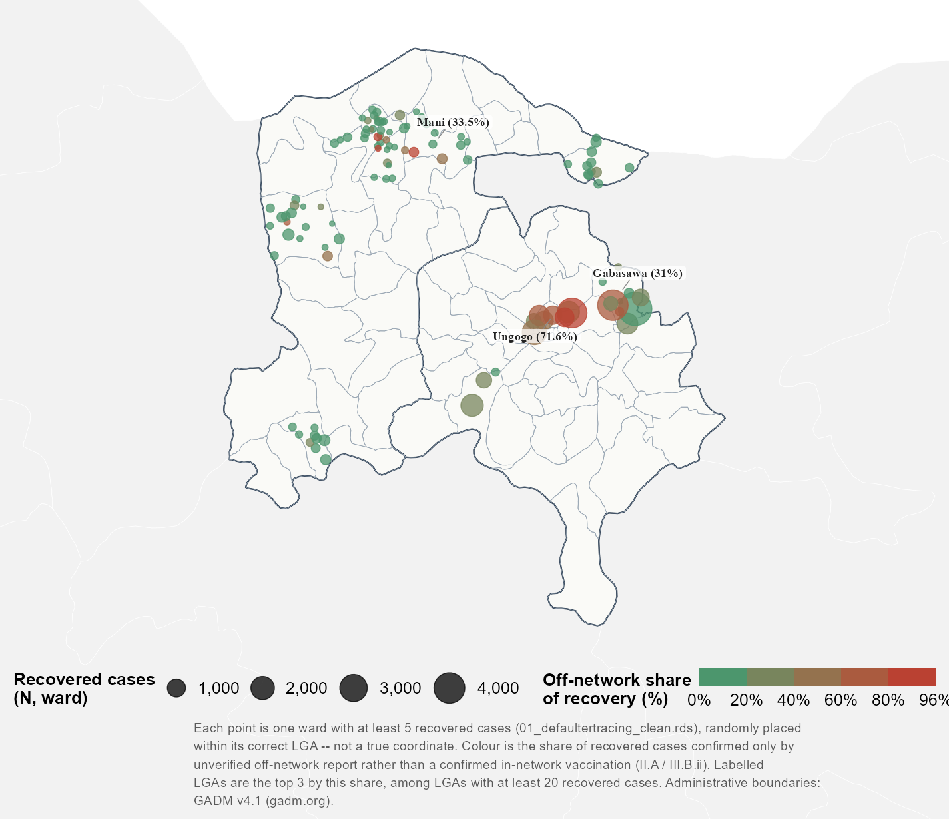
Figure 3.7b. Off-network share of recovered defaulters, by ward
The same off-network share of recovery, mapped by ward, showing whether it clusters within particular LGAs or spreads evenly, a distinction the pooled state-level comparison cannot make visible.
This is the clearest single illustration in this thesis of the verification gap described in Section II.A: a programme reporting the permissive figure, plausible given the underlying protocol treats a card check as sufficient confirmation, would report a rate substantially higher than a stricter standard supports, a gap that reflects what the underlying records can verify rather than how well tracing is actually working.

C. Weather model

i. Descriptive overview
Daily facility visit counts are heavily zero-inflated: a substantial share of LGA-days record no visits at all, and the variance of these counts exceeds their mean by a wide margin in every LGA examined, confirming the overdispersion anticipated in Section II.D and ruling out a standard Poisson specification on theoretical grounds. A closer look at which days are quiet suggests a calendar-driven rather than weather-driven explanation: zero-visit days cluster around specific weekdays and known religious holiday periods rather than spreading evenly across the year, a pattern more consistent with scheduled closures and social rhythm than any environmental driver, setting up Section IV’s discussion of why social and operational factors may dominate over weather here.
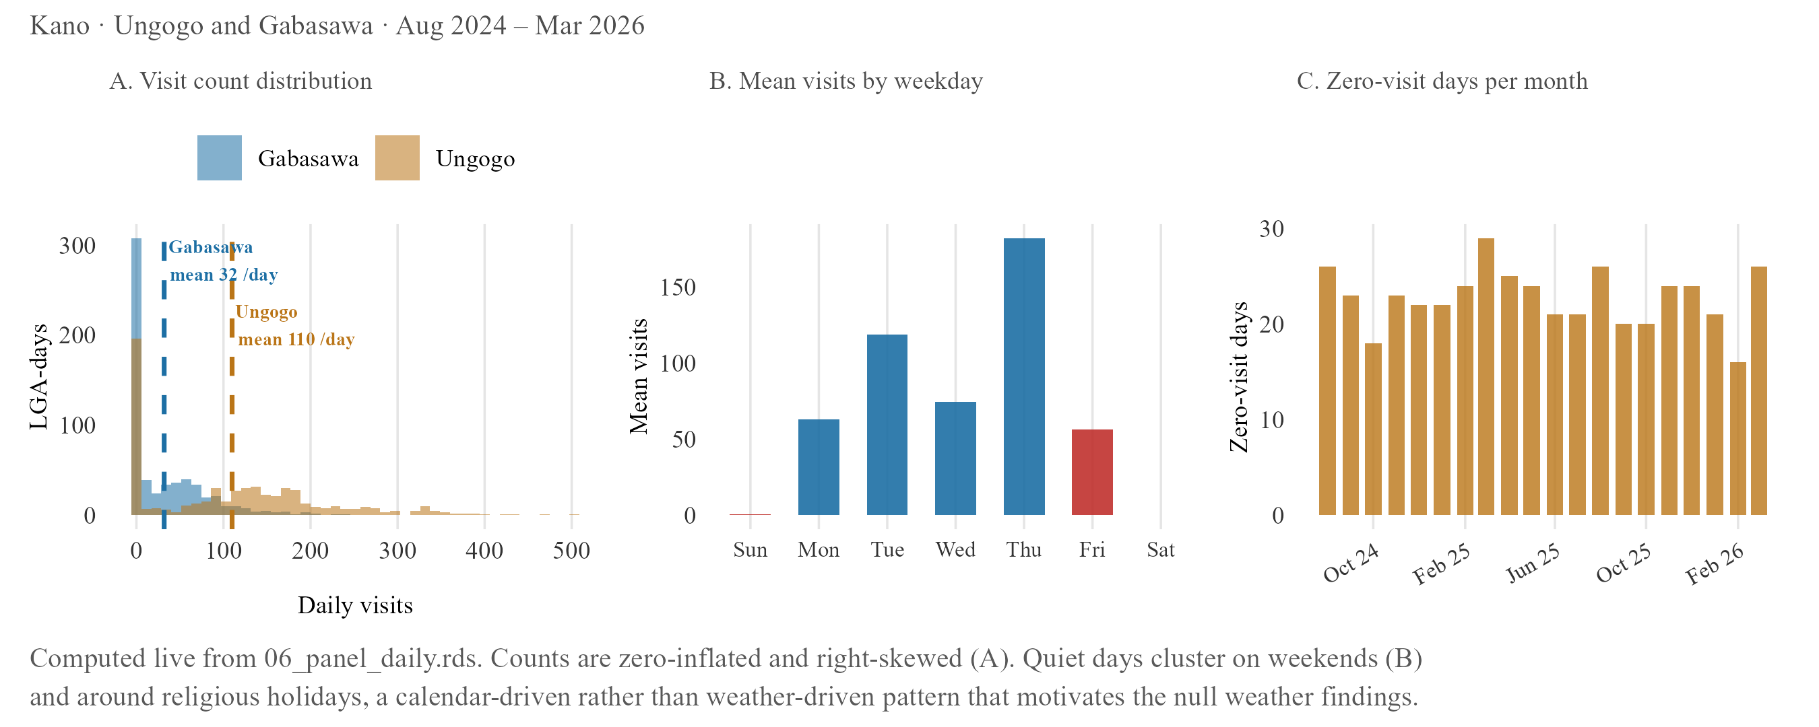
Figure 3.8. Daily facility visit diagnostics
Four-panel diagnostic: the visit-count distribution’s heavy mass at zero, weekday clustering of zero-visit days (lowest Friday/weekend, highest Thursday), their concentration around holiday periods, and the variance-to-mean ratio confirming overdispersion.

ii. Main results
None of the three weather variables tested, rainfall, heat, and vegetation, show a significant or directionally consistent effect on daily visit counts under the primary negative binomial specification; heat moves in the direction a deterrence hypothesis would predict, rainfall and vegetation do not. A small number of monthly specifications return a nominally significant coefficient, but each traces to a structural artefact of a thin, two-site monthly panel rather than a genuine weather effect: too few degrees of freedom for a trustworthy standard error, or fixed effects that strip out all within-site variation and leave the coefficient describing a fixed difference between two places rather than a response to changing conditions. The properly powered daily specifications are cleanly null throughout.
Table 3.2. Weather model — main results
 | Variable | Exposure measure | Coef. [95% CI] | Panel | Fixed effects | N | R²
W1 | Precipitation | Monthly precipitation anomaly (% of long-term average) | 0.004*** [0.004, 0.004] | Monthly | LGA | 40 | 0.923
W2 |  | Daily precipitation anomaly (% of long-term average) | -0.000 [-0.004, 0.004] | Daily | LGA, DOW, month-year | 1216 | 0.104
W3 | Heat | Extreme heat day (UTCI ≥ 38°C, binary) | 0.098 [-0.037, 0.233] | Daily | LGA, DOW, month-year | 1216 | 0.104
W4 |  | Daytime mean UTCI (°C, centred) | 0.045*** [0.02, 0.07] | Daily | LGA, DOW, month-year | 1216 | 0.105
W5 | Vegetation | NDVI seasonal level (vim, centred) | -0.029 [-0.662, 0.604] | Monthly | LGA | 40 | 0.150
W6 |  | NDVI within-baseline anomaly (viq, centred) | -0.062*** [-0.062, -0.062] | Monthly | LGA, month-year | 40 | 0.264
Primary negative binomial coefficients for rainfall, heat and vegetation on daily visit counts, with 95% CIs. The properly powered daily specifications (W2, W3, W4) are cleanly null; the starred monthly specifications (W1, W6) are small-sample or fixed-effect artefacts of a thin two-site panel, not evidence of a real weather effect. ** p < 0.05 *** p < 0.01
The null result also survives two robustness checks built specifically to address the concerns raised in Section II.C.ii. Re-estimating with an exposure offset, which converts the outcome to a rate relative to each LGA’s enrolled population rather than a raw count, does not surface a significant effect for any of the three variables. Replacing the linear weather term with a spline, which allows a non-linear relationship, likewise finds nothing: the null is not an artefact of assuming a straight-line relationship where a curved one exists.
Table 3.3. Weather model — offset and spline robustness
Variable | Term | Original_CI | Offset_CI | NB_offset_CI | Spline_check
Precipitation (daily, P4) | precip_anomaly_pct | 0.001 [-0.003, 0.005] | 0.000 [-0.004, 0.004] | -0.000 [-0.004, 0.004] | Yes — at least one spline term p<0.05
Heat, binary (D3) | extreme_heat_38 | -0.056 [-0.23, 0.118] | -0.057 [-0.231, 0.117] | 0.097 [-0.032, 0.226] | N/A — binary term, no spline built
Heat, continuous UTCI (D4) | utci_dt_c | 0.019 [-0.008, 0.046] | 0.019 [-0.008, 0.046] | N/A — NB-offset only built for binary heat (D3) | Yes — at least one spline term p<0.05
NDVI, vim level (N4) | vim_c | -7.653*** [-7.653, -7.653] | 1.922*** [1.922, 1.922] | 1.915*** [1.597, 2.233] | Yes — at least one spline term p<0.05
NDVI, viq anomaly (N2) | viq_c | -0.062*** [-0.062, -0.062] | -0.002*** [-0.002, -0.002] | N/A — NB-offset only built for vim (N4) | N/A — no spline built for viq
Offset and spline re-estimates alongside the primary specification. Coefficients shift somewhat when an NDVI offset is applied, but the two daily heat/precipitation specifications remain null throughout; every variable shows at least one spline term reaching p<0.05, worth a closer look without changing the headline null conclusion.
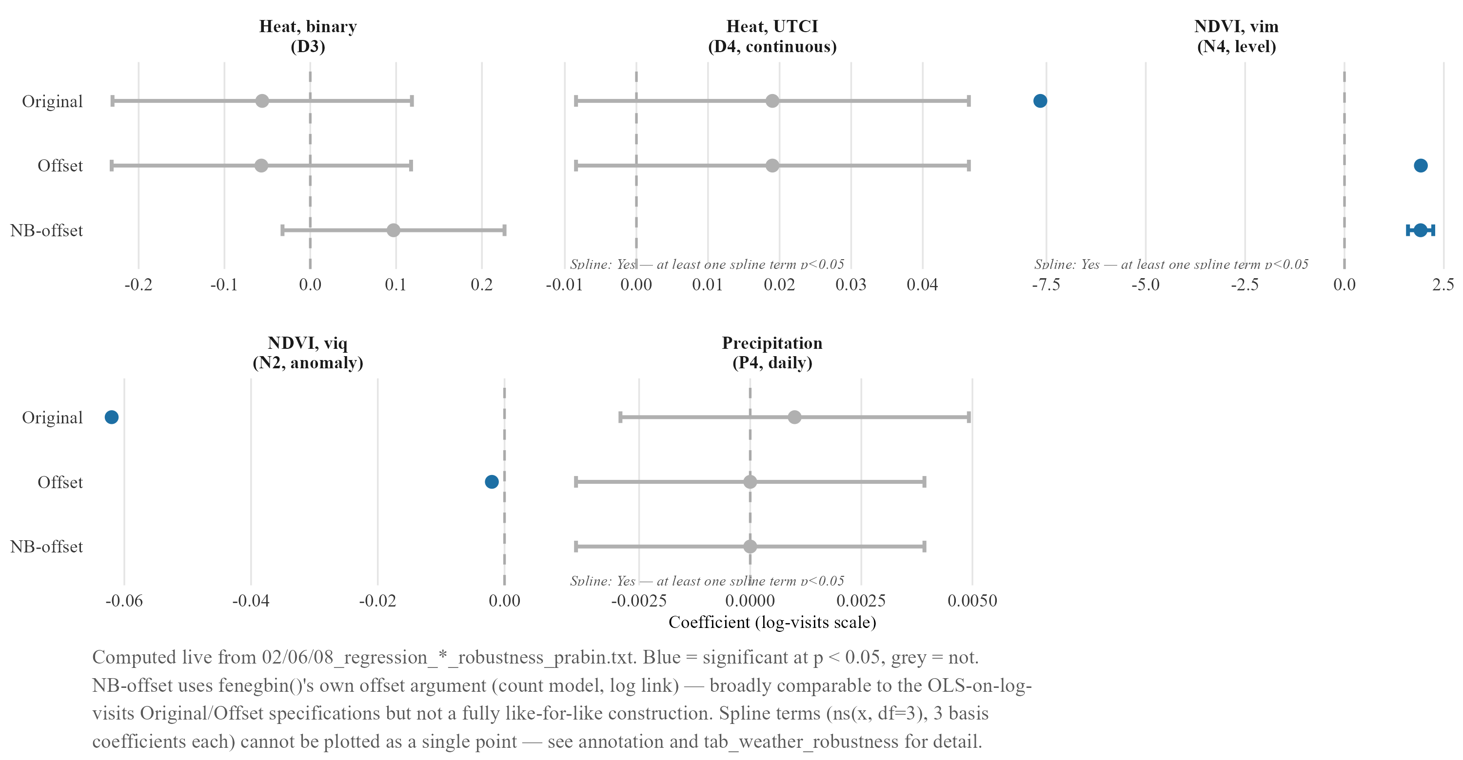
Figure 3.9. Weather effect estimates across specifications — offset, NB-offset and spline robustness
Same coefficients as Table 3.3, plotted with CIs across the three specifications side by side. Facility- and LGA-level heterogeneity checks found isolated significant effects at only one or two sites out of roughly twenty tested, consistent with noise rather than a systematic effect.
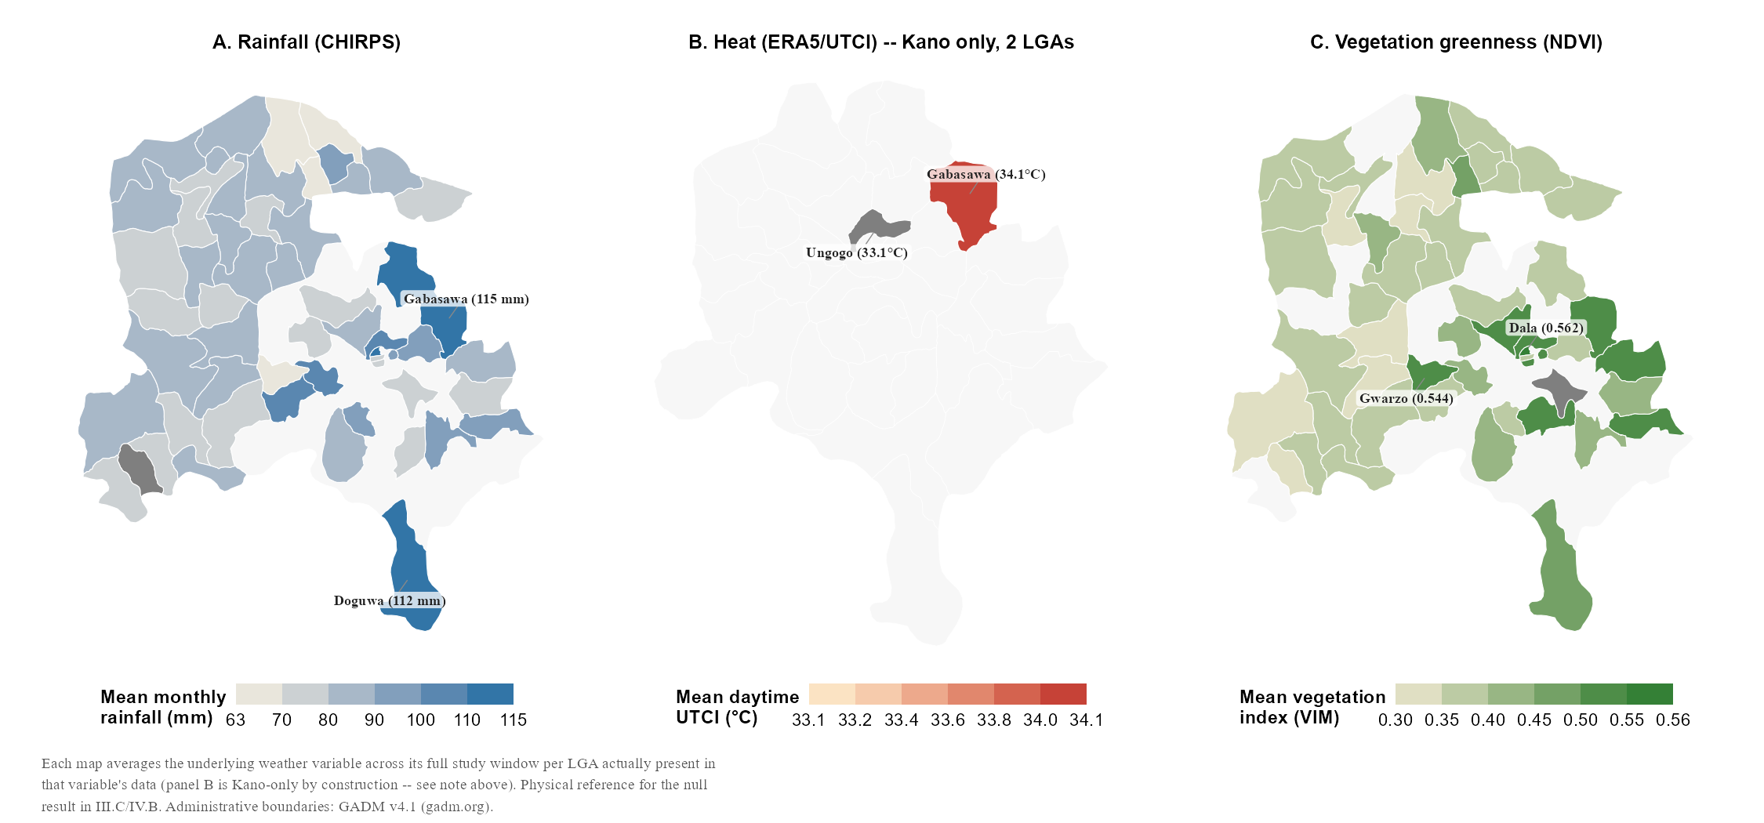
Figure 3.9b. Weather variables across Kano and Katsina’s LGAs
Rainfall, heat and vegetation averaged by LGA across the full study window, giving the null result above a physical reference. Panel B (heat) covers only Ungogo and Gabasawa in Kano, the full extent of the ERA5/UTCI panel used in the heat model, not a display choice.

iii. Comparison against log-transformed OLS
A log-transformed OLS specification was estimated alongside the primary negative binomial models for all three weather variables, as set out in Section II.D. Across precipitation, heat, and vegetation, OLS agrees with the primary NB specification in direction and in the absence of significance, so the null result reported above does not depend on which of the two specifications is used.
Table 3.4. Weather model — negative binomial and OLS compared
Variable | Specification | Coef | SE | CI | Sig
Precipitation | Negative binomial — counts (primary) | 0.000 | 0.002 | [-0.0039, 0.0039] | n.s.
Precipitation | OLS — log(visits + 1) | 0.001 | 0.002 | [-0.0029, 0.0049] | n.s.
Heat | Negative binomial — counts (primary) | 0.098 | 0.069 | [-0.0372, 0.2332] | n.s.
Heat | OLS — log(visits + 1) | -0.056 | 0.089 | [-0.2304, 0.1184] | n.s.
NDVI | Negative binomial — counts (primary) | -0.029 | 0.323 | [-0.6621, 0.6041] | n.s.
NDVI | OLS — log(visits + 1) | -0.059 | 0.338 | [-0.7215, 0.6035] | n.s.
Negative binomial and log-OLS coefficients side by side for all three weather variables. Both specifications agree on direction and non-significance throughout; precipitation is the closest either comes to a conventional threshold, and even there both remain within the null interpretation given in Section III.C.ii.

IV. Discussion and Synthesis

A. What the data can show: reading the zero-dose and recovery findings together
Distance predicts ZD status once the strict definition is applied, an 87 per cent increase in the odds per additional kilometre, and shows almost nothing under the primary definition, a non-significant 4 per cent increase. Distance predicts almost nothing about recovery: once a child is flagged and a tracing attempt begins, the same variable shows no detectable effect at all, consistent with recovery here running through SMS and phone contact rather than physical travel (Section II.C.i). Section IV.F brings these quantitative findings together with corroborating field engagement (Table 4.2); the discussion here focuses on what the regressions alone show.
This split says something useful about DATHARM’s two stated problems: finding zero-dose children, and getting them vaccinated once found. They are not the same problem and do not respond to the same fix: physical reach, more outreach points, shorter travel distances, matters for the first, while the second depends far more on contact method and speed than on geography, an asymmetry sharpened by the strict-versus-primary ZD definition split, since distance only shows its full strength once zero-dose means genuinely no contact at all.
The enumeration gap described in Section II.A (roughly one in five households missed, by the Kano coordinator’s estimate) cannot be checked against MCHTrack’s own records, but it points the same way as the regression: distance almost certainly shapes who gets found at all, in ways this analysis, built entirely from children eventually enumerated, has no way to observe directly.
Field conversation with DATHARM’s Kano coordinator adds a further layer: recovery rates by contact method run in opposite directions in Kano and Katsina, home visits ahead in Kano and SMS ahead in Katsina (Section III.B.i). This thesis’s pooled estimate cannot on its own distinguish a state-level operational difference from the attempt-sequencing question raised in Section III.B.i, and treating the pooled SMS coefficient as evidence that SMS is the better channel would overstate what either the state-split numbers or the sequencing caveat can support.
The strict-versus-permissive recovery gap belongs in the same discussion: 42.6 per cent pooled under the strict definition, rising to 77.2 per cent under the permissive one (Section III.B.ii). This gap is not noise; it follows directly from the protocol in Section II.A, which allows a tracing case to close on the strength of a card check, with no record of what the card actually showed. Whichever figure DATHARM reports, the distance between the two is a fact about the limits of the underlying records, and no amount of further modelling will close it. Taken together, the same caution applies throughout this thesis’s first two models: each coefficient is real, but each also marks the edge of what MCHTrack’s records can confirm on their own.

B. Why the weather model came back null: reading it against Sindh and Miami
The same test has been run twice elsewhere, and both times it found something. Siddiqi et al. (2025) linked daily heat data to a real-time immunisation registry in Sindh, Pakistan, and found heat wave days significantly reduced immunisation delivery, outreach hit harder than fixed-site delivery; Samano et al. (2021) linked daily heat and precipitation to an HIV clinic registry in Miami, and found both variables significantly increased missed appointments. Neither registry carries the enumeration or verification gaps documented in Section II.A: these comparators are unlikely to be entirely clean, but cleaner than MCHTrack on the dimensions this thesis can check.
Table 4.1. This thesis against the two closest registry-based precedents
Study | Setting | Registry | Exposure | Result
This thesis (2026) | Kano & Katsina, Nigeria | MCHTrack zero-dose tracking | Rainfall, heat, NDVI | Null — no significant effect on any variable (see weather table)
Siddiqi et al. (2025) | Sindh, Pakistan | Provincial electronic immunisation registry (132M doses) | Heat wave days | Significant reduction — outreach hit hardest (−21.2%), fixed-site least (−5.8%)
Samano et al. (2021) | Miami, USA | HIV clinic appointment registry | Extreme heat & precipitation | Significant increase in missed appointments (+13% for extreme precipitation)
Side-by-side comparison of outcome, weather exposure, direction and significance of effect, and data-quality caveats across this thesis, Siddiqi et al. (2025) and Samano et al. (2021), making explicit that this thesis’s null sits against two comparators that both found significant effects.
Five explanations are worth weighing. They are not mutually exclusive, and several likely operate together.
The first concerns what dominates the social calendar. Zero-visit days in this dataset cluster around specific weekdays and known religious holidays rather than spreading evenly across the year (Section III.C.i), leaving little room for weather to explain anything further even if a real effect exists underneath it. This matches the field: across conversations with DATHARM staff and two primary healthcare centre visits near Abuja, nobody named weather as a barrier even when discussion turned directly to attendance; the barriers named instead were almost entirely social, gendered, and economic, echoing caregiver-focus-group and health-system-constraint studies elsewhere in northern Nigeria that likewise never mention weather (Bolarinwa et al., 2025; Etim et al., 2025). A null finding alongside this body of caregiver-reported barriers looks less like an absence and more like confirmation that other factors are doing the explanatory work weather might otherwise be expected to do.
The second concerns a larger, more severe shock crowding out a gentler one. Vaccination access across the wider Sahel tracks conflict and administrative breakdown far more closely than any environmental variable, with ZD rates in conflict-affected states reaching as high as 43 per cent (Sabahelzain et al., 2025). Kano and Katsina sit within this same security environment, and a population already absorbing insecurity, displaced administrative capacity, and disrupted supply chains may simply have little remaining sensitivity to a comparatively mild stressor like a hot day or a rainy week; conflict, in this setting, is the more likely constraint on a household’s limited capacity to respond, ahead of weather.
The third concerns time, not presence or absence. Heat does not straightforwardly suppress outdoor activity so much as redistribute it within the day: cellphone location data from over ten thousand parks in China shows hourly temperatures above 30°C and 35°C depress outdoor leisure activity by 5 and 13 per cent respectively, much of the apparent decline really substitution toward cooler hours (Zheng et al., 2023). MCHTrack’s facility visits table records only a date, not a time, so a caregiver who visits earlier or later on a hot day rather than not at all leaves this analysis with no way to detect that shift.
The fourth concerns heat’s effect on a caregiver’s time and energy rather than the act of travel itself. Wearable-sensor data from subsistence farmers in Burkina Faso found heat stress measurably increased physical strain during labour and worsened sleep, with farmers shifting tasks to cooler hours (Eggert et al., 2025), and much of the Sahel’s rural population works outdoors for part of most days. A hot day may deter a clinic visit through exhaustion and reduced household labour capacity rather than travel discomfort, a mechanism this analysis cannot separate from simple deterrence, since both produce the same null signal.
The fifth concerns the outcome variable itself, and is less comfortable than the first four: Siddiqi’s and Samano’s registries both record a clinical encounter that either happened or did not, while MCHTrack’s facility visits table carries the enumeration and verification problems set out across Section II, so a null result here cannot carry the same weight as one against a cleaner outcome.
Taken together, weather may genuinely matter less here than in Sindh or Miami because conflict and social barriers dominate the explanatory space, because the data cannot see the time-shifting or labour-capacity channels through which a weather effect would most likely operate, or because the data itself is too noisy to detect a real but small effect. This thesis cannot distinguish between these explanations with the data as currently structured, a limitation Section V returns to.

C. The limits of ward-level analysis: what the Kano/Katsina asymmetry teaches about this kind of data more broadly
Ward-level analysis built on routine programme data tends to look most informative exactly where the underlying records are least reliable, since the same gaps that produce noisy data, incomplete enumeration, inconsistent verification, duplicate entries, can also produce the kind of extreme value a residual analysis is designed to detect. Cleaner data, by contrast, may simply show less variation, not because the underlying reality is more even, but because there is less room for error to generate an outlier. A reader working under time pressure has reason to focus on the largest numbers, even though those numbers may rest on the weakest evidence.
Section III.A.ii illustrates this directly. Katsina’s ward residuals show the largest deviations from the model’s predictions anywhere in this analysis, and Katsina is also the state with the documented duplication problem (38.9 per cent of facility visit records) and the verification gap with the most room to affect the underlying numbers; Kano, cleaner throughout, shows a flatter spread. The appropriate response is not a different statistical model but a verification step before any ward-level finding informs a resource decision: a flagged ward is a candidate for a field visit or a card check, not a confirmed priority (Section V). The same caution applies, in a different form, to the weather null just discussed: in both cases, the least reliable parts of the record are exactly where this thesis’s findings are hardest to take at face value.

D. Demand-side scope as a critical lens
This last point cuts in one direction throughout the section so far, toward where the data is too thin to confirm a finding. It is worth asking whether it also cuts the other way, toward a category of explanation this thesis has not been able to test at all. Section IV.B raised conflict and administrative disruption as a shock potentially severe enough to crowd out weather in shaping caregiver behaviour; a parallel mechanism operates on the supply side, where the evidence is more direct. Nigeria’s national vaccine stock performance dashboard found stock-reporting gaps concentrated specifically in conflict-affected areas of the northeast, where basic primary healthcare delivery is itself disrupted (World Economic Forum, 2014), and separate survey work across 35 immunisation clinics in Ile-Ife, southwest Nigeria, found only 29 per cent of vaccinators kept any record of vaccine stock-on-hand at all (Ojo et al., 2019). Weak supply-side recordkeeping is not a unique limitation of MCHTrack; it reflects a broader pattern across Nigerian routine immunisation delivery.
This blind spot is not hypothetical. A Missed Opportunities for Vaccination assessment in Ondo State, using exit interviews with caregivers who had already reached a health facility, found 32.8 per cent left without receiving an indicated vaccine, the large majority during a visit made for an unrelated reason where no one offered the vaccine, rather than a visit where the vaccine itself was unavailable (Fatiregun et al., 2021). MCHTrack has no equivalent mechanism for capturing this: a facility visits row is created only when a vaccination is actually administered, so a caregiver who reaches a clinic and leaves without one leaves no trace at all. The scale of this gap cannot be estimated from MCHTrack’s own records, but evidence from elsewhere in Nigeria suggests it is unlikely to be small.
This returns the discussion to the weather null in Section IV.B, from the supply side rather than the demand side. A flat relationship between weather and visit counts could mean caregivers are genuinely undeterred by heat or rainfall, or it could mean a real weather effect is being diluted by a supply-side gap of unknown but potentially substantial size, the same gap the Ondo State exit interviews suggest exists elsewhere in the country. MCHTrack cannot distinguish a quiet day caused by low demand from one caused by caregivers arriving and being turned away, so the null finding in Section IV.B should be read with this ambiguity attached, not as a clean statement that weather has no bearing on care-seeking here.

E. Fieldwork as contextual grounding
The field material referenced throughout this chapter, conversations with DATHARM staff, two field visits to primary healthcare centres in the wider Abuja area, and internal reports shared by DATHARM, is not an independent qualitative study: no structured protocol was applied and no formal coding carried out. Its purpose is to help interpret the quantitative findings against what people working with the programme observe directly, in the manner of informal colleague commentary rather than a parallel research method, and it is where the household enumeration gap and the off-network verification gap described in Section II.A first surfaced. Engaging directly with the people and systems generating the data under analysis is standard good practice for applied programme research, not a compromise that needs excusing.
Conversations covered DATHARM’s Kano and Katsina coordinators, the data manager, and staff encountered during the two facility visits, spanning enumeration practice, tracing protocol, and day-to-day barriers caregivers are seen to face. This material is used only where it corroborates or usefully complicates a finding that already stands on its own quantitatively, not as independent confirmation (Section IV.F).

F. Closing synthesis: convergence across methods
Three of this thesis’s findings, distance, timing, and recordkeeping, were each corroborated by field engagement at the point each came up above. Weather’s apparent irrelevance was corroborated the same way, but by absence rather than agreement: nobody closest to the programme named it as a barrier either. None of this corroboration was gathered through a structured qualitative method, as Section IV.E made clear; it was observed informally, and is used here only where it supports a finding that already stands on its own.
Table 4.2. Convergence of quantitative findings and field observation
Theme | Quantitative | Field | Convergence
Distance | Predicts zero-dose status (β = 0.042 primary; 0.627 strict). No effect on recovery. | Coordinator: distance is the barrier to being found, not to being recovered by phone. | Agreement
Timing | SMS contact predicts recovery (β = 0.444). | Long-open cases described as harder to close; contact speed matters more than reach. | Agreement
Recordkeeping | Strict recovery 42.6% vs permissive 77.2%. | Card check closes a case with no record of what the card showed. Confirmed as protocol. | Agreement
Weather | Null across rainfall, heat, and NDVI, all specifications. | No programme staff named weather as a barrier in any conversation, even when prompted. | Agreement by absence
Four themes, distance, timing, recordkeeping and weather, each pairing a quantitative finding with the field material described in Section IV.E, and showing where the two agree (distance, timing, recordkeeping) versus where agreement is really an absence of any field mention at all (weather).
This agreement between a regression coefficient and an informal field account deserves to be taken seriously, but not overstated: it is not independent confirmation in any rigorous sense, since the field material was never collected with the structure that would require. What it offers instead is a check against a real risk of working with data like MCHTrack’s: a coefficient can be statistically significant and still tell you very little true about the world, simply because the data behind it is thin in the wrong places. Where the regression and the field account agreed, that risk looks smaller; where they did not, the largest regression deviations in Section III.A.ii sat in the state with the least reliable records, and the supply-side gap raised in Section IV.D sits entirely outside what either could see. A dissertation built on routine digital health records must state plainly where those records can be relied upon and where they cannot.

V. Conclusion and Recommendations

A. Implications by driver
This thesis asked what predicts ZD status and tracing effectiveness in MCHTrack, but the pattern it finds is not specific to one programme. Any community-health-worker system layered onto routine immunisation delivery in a setting like Kano and Katsina faces the same underlying split: finding children the system has missed, and getting them vaccinated once found, are different problems that respond to different levers, and a system’s reported performance is only as trustworthy as what its data-entry protocol lets it verify. MCHTrack illustrates both halves of that split concretely.
Distance is the strongest predictor of ZD status once the strict definition is applied, so continued or expanded outreach into the most distant wards stands the best chance of finding children the current system is most likely to miss, an urgency sharpened by the household enumeration gap: if roughly one in five households go unreached, as DATHARM’s own Kano coordinator estimates, the children furthest from a facility are also likely the least likely to be found at all. Distance loses almost all of its predictive power once a child is flagged and tracing begins, and SMS contact is associated with higher recovery in the pooled data, though Section III.B.i’s caveats apply: the effect is driven more by Katsina than Kano, and this thesis cannot yet separate a genuine channel effect from attempt sequencing. Rather than invest in one channel on the strength of the pooled coefficient alone, the more defensible near-term step is the attempt-order analysis flagged below, so any shift in contact strategy rests on evidence the current data can actually support. The broader implication for comparable programmes across the region is the same: distance-based targeting belongs at the identification stage, not the follow-up stage, wherever recovery can be attempted by phone rather than a return visit.
The clearest single recommendation concerns recovery reporting itself: 42.6 per cent under the strict definition, 77.2 per cent under the permissive one. Neither figure is wrong, they answer different questions, and the gap between them is large enough to change how a funder or DATHARM’s own leadership might judge performance. Any reported recovery figure should state which definition produced it, and where possible both should be reported side by side. This is not a problem unique to MCHTrack: any immunisation programme, digital or paper-based, that allows a case to close on an unverified confirmation step faces the same choice, and the same discipline, naming which one is being reported, applies well beyond this setting. The gap was never hidden in the data; it was only ever uncollapsed.

B. What remains unresolved about weather, and why
Section IV.B offered five explanations for the weather null: social and operational rhythm may already absorb most of the swing in daily visits before weather can register; conflict and administrative disruption may crowd out a gentler stressor entirely; a real response to heat may exist within a single day, invisible to data recorded only by date; heat may act through labour and household time rather than travel deterrence; and the outcome variable itself may simply be too noisy to detect an effect that is real but small.
This thesis cannot choose between these five, and the temptation to choose anyway is worth resisting on purpose: conflict dominance is the strongest candidate by reputation, but picking it as the answer would produce a tidier, unjustified conclusion, since nothing here rules out the other four. A structural-zero mixture model, separating the process generating zero-visit days from the count process on days something happens, was considered as a more direct test and not built given this project’s timeline; it remains the clearest next modelling step. Two explanations point directly to what MCHTrack would need to capture next: a time-of-day field on facility visits, and some visibility into supply-side stockouts. A related next step on the recovery side is ranking tracing attempts chronologically within each child, using the existing patient_id and tracing-date fields, to test whether SMS’s association with recovery reflects channel effectiveness or simply which cases reach a second attempt.

C. Limitations
Four limitations have run through this thesis. MCHTrack records children who are found, not children who exist, and the enumeration gap has no field anywhere in the system, so every ZD count inherits it silently. Katsina’s facility visit records carry a documented duplication problem, worked around here but not repaired, and its reliability degrades further later in the study period, the reason the weather model uses Kano alone. Recovery can be confirmed by a card check with no record of what the card showed, producing the strict-versus-permissive gap above, and the tracing table’s lack of an attempt-order field is a related gap (Section III.B.i). This analysis also tested demand-side explanations only, a blind spot evidence from elsewhere in Nigeria suggests is unlikely to be small.
A further limitation concerns what could not be measured even in principle. Household socioeconomic status, maternal education, and birth order are absent from MCHTrack’s fields entirely, and the system cannot check whether a caregiver’s account of a vaccination history was accurate. None of this is unique to MCHTrack, and the three structural patterns behind it are worth stating as general propositions rather than programme-specific complaints: ward-level analysis built on routine digital health records tends to look most informative exactly where the records are least reliable; any system allowing a case to close on an unverified confirmation step will generate a gap between what it reports and what it can prove; and a system built around demand-side identification will, by construction, be blind to supply-side failure. These are reasonable defaults for any digital immunisation-tracking system operating in a similar low-resource, conflict-affected setting, and organisations running comparable programmes across the region may find them worth checking against their own data. The specific numbers here belong to Kano and Katsina in this period; none of it is claimed to travel further without that check.

D. Future research directions
Two directions extend beyond this thesis’s setting. The first is whether weather affects immunisation-seeking behaviour in this region at all, properly tested through a design built for the purpose: a longer time span letting weather vary independently of any single conflict episode or religious calendar, and fields capturing visit timing and supply-side stockouts directly. The second concerns how digital immunisation registries perform across contexts: Mantel et al. (2025) evaluated electronic immunisation registries and logistics systems across Guinea, Honduras, Rwanda, and Tanzania, but no conflict-affected or Sahelian country was included. Applying the same framework to MCHTrack and comparable systems in Nigeria and the wider Sahel would test whether the enumeration gap, the verification gap, and the supply-side blind spot identified here are general features of this kind of system or specific to this setting.
MCHTrack was built to find children the health system was missing. This thesis set out to do the same to the data itself, and to the question of weather riding alongside it. A record is not the same as the life it tries to follow. A null result is not the same as an absence. The distance between what was found and what remains unresolved is where the real work of reaching every child will always have to continue.

References
Bergé, L. (2018) ‘Efficient estimation of maximum likelihood models with multiple fixed-effects: the R package FENmlm’, CREA Discussion Papers, 2018-13.
Blanford, J.I., Kumar, S., Luo, W. and MacEachren, A.M. (2012) ‘It’s a long, long walk: accessibility to hospitals, maternity and integrated health centers in Niger’, International Journal of Health Geographics, 11, p. 24.
Bolarinwa, O.A., Salaudeen, G.A., Lar, L., Alhaffar, M., Abdelmagid, N., McGowan, C.R., Adesoro, O., Valentine, P., Ahmed, T., Clarke, A., Makunja, S. and Akande, T.M. (2025) ‘Barriers and enablers to childhood immunization in high zero-dose burden communities in Kano and Lagos states, Nigeria’, Vaccine, 64, p. 127754.
Carnell, M.A. and Guyon, A.B. (1990) ‘Nutritional status, migration, mortality, and measles vaccine coverage during the 1983–1985 drought period: Timbuktu, Mali’, Journal of Tropical Pediatrics, 36(3), pp. 109–113.
Copernicus Climate Change Service, Climate Data Store (2026) Thermal Comfort Indices Derived from ERA5 Reanalysis. Available at: https://cds.climate.copernicus.eu/datasets/derived-utci-historical (Accessed: 14 May 2026).
DATHARM (2026) MCHTrack for Zero Dose Project. Available at: https://datharm.org/ (Accessed: June 2026).
Di Napoli, C., Barnard, C., Prudhomme, C., Cloke, H.L. and Pappenberger, F. (2021) ‘ERA5-HEAT: a global gridded historical dataset of human thermal comfort indices from climate reanalysis’, Geoscience Data Journal, 8(1), pp. 2–10.
Eggert, E., Gunga, H., Sié, A., Ouermi, L., Ouédraogo, W.A., Kwaro, D., Sauerborn, R., Bunker, A., Barteit, S., Bärnighausen, T. and Maggioni, M.A. (2025) ‘Physical effort during labour and behavioural adaptations in response to heat stress among subsistence farmers in Burkina Faso: a gender-specific longitudinal observational study’, The Lancet Planetary Health, 9(12), 101344.
Etim, E.O., Odiachi, A., Dougherty, L., Alabi, M., Adetunji, A. and Adedimeji, A. (2025) ‘Understanding caregivers’ and community influencers’ perspectives on the barriers to childhood immunisation in Northern Nigerian States with public-private partnerships in routine immunisation programme’, BMC Public Health, 25, p. 1471.
Farrenkopf, B.A., Zhou, X., Shet, A., Olayinka, F., Carr, K., Patenaude, B., Chido-Amajuoyi, O.G. and Wonodi, C. (2023) ‘Understanding household-level risk factors for zero dose immunization in 82 low- and middle-income countries’, PLOS One, 18(12), e0287459.
Fatiregun, A.A., Nic Lochlainn, L., Kaboré, L., Dosumu, M., Isere, E., Olaoye, I., Akanbiemu, F.A., Olagbuji, Y., Onyibe, R., Boateng, K., Banda, R. and Braka, F. (2021) ‘Missed opportunities for vaccination among children aged 0–23 months visiting health facilities in a southwest State of Nigeria, December 2019’, PLOS One, 16(8), e0252798.
Federal Ministry of Health and National Primary Health Care Development Agency (2013) National Routine Immunization Strategic Plan 2013–2015: Intensifying Reaching Every Ward through Accountability. Abuja: Federal Republic of Nigeria.
Funk, C., Peterson, P., Landsfeld, M., Pedreros, D., Verdin, J., Shukla, S., Husak, G., Rowland, J., Harrison, L., Hoell, A. and Michaelsen, J. (2015) ‘The climate hazards infrared precipitation with stations — a new environmental record for monitoring extremes’, Scientific Data, 2, 150066.
GADM (2026) GADM database of Global Administrative Areas, version 4.1. Available at: https://gadm.org (Accessed: July 2026).
Gavi, the Vaccine Alliance (2025) In Katsina, Nigeria, a homegrown mobile app is helping get vaccines to vulnerable kids. Available at: https://www.gavi.org/vaccineswork/ (Accessed: June 2026).
GBD 2023 Vaccine Coverage Collaborators (2025) ‘Global, regional, and national trends in routine childhood vaccination coverage from 1980 to 2023 with forecasts to 2030: a systematic analysis for the Global Burden of Disease Study 2023’, The Lancet, 406(10500), pp. 235–260.
Ghinai, I., Willott, C., Dadari, I. and Larson, H.J. (2013) ‘Listening to the rumours: what the northern Nigeria polio vaccine boycott can tell us ten years on’, Global Public Health, 8(10), pp. 1138–1150.
Guagliardo, M.F. (2004) ‘Spatial accessibility of primary care: concepts, methods and challenges’, International Journal of Health Geographics, 3, p. 3.
Haque, M.R., Parr, N. and Muhidin, S. (2019) ‘Parents’ healthcare-seeking behavior for their children among the climate-related displaced population of rural Bangladesh’, Social Science & Medicine, 226, pp. 9–20.
Jegede, A.S. (2007) ‘What led to the Nigerian boycott of the polio vaccination campaign?’, PLOS Medicine, 4(3), e73.
Joseph, N.K., Macharia, P.M., Ouma, P.O., Mumo, J., Jalang’o, R., Wagacha, P.W., Achieng, V.O., Ndung’u, E., Okoth, P., Muñiz, M., Guigoz, Y., Panciera, R., Ray, N. and Okiro, E.A. (2020) ‘Spatial access inequities and childhood immunisation uptake in Kenya’, BMC Public Health, 20, p. 1407.
MacDonald, N.E. and SAGE Working Group on Vaccine Hesitancy (2015) ‘Vaccine hesitancy: definition, scope and determinants’, Vaccine, 33(34), pp. 4161–4164.
Mantel, C., Hugo, C., Federici, C., Sano, N., Camara, S., Rodriguez, E., Castillo, L., Condo, J., Irakiza, P., Sabi, I., Nyanda, E., Olomi, W., Cavazza, M., Mangiaterra, V., Verykiou, M., Ferenchick, E., Torbica, A., Cherian, T. and Malvolti, S. (2025) ‘Impact of electronic immunization registries and electronic logistics management information systems in four low- and middle-income countries: Guinea, Honduras, Rwanda, and Tanzania’, Vaccine, 54, 127066.
Mills, A. (2005) ‘Mass campaigns versus general health services: what have we learnt in 40 years about vertical versus horizontal approaches?’, Bulletin of the World Health Organization, 83(4), pp. 315–316.
Miraj, F., Iftikhar, S., Siddique, M., Dharma, V.K., Shah, M.T., Siddiqi, D.A. and Chandir, S. (2024) ‘Leveraging data from a provincial electronic immunization registry to analyze immunization coverage, timeliness, and defaulters among 8.8 million children from the 2018 to 2023 birth cohorts in Sindh Province, Pakistan’, Vaccines, 12(12), p. 1327.
Nagata, J.M., Epstein, A., Ganson, K.T., Benmarhnia, T. and Weiser, S.D. (2021) ‘Drought and child vaccination coverage in 22 countries in sub-Saharan Africa: a retrospective analysis of national survey data from 2011 to 2019’, PLOS Medicine, 18(9), e1003678.
National Primary Health Care Development Agency (NPHCDA) (2022) Zero-dose children data, Kano State. Abuja: NPHCDA.
Ojo, T.O., Ijadunola, M.Y., Adeyemi, E.O., Adetunji, O.O., Adurosakin, F.O., Adeyinka, A.M. and Adeyelu, C.O. (2019) ‘Challenges in the logistics management of vaccine cold chain system in Ile-Ife, Osun State, Nigeria’, Journal of Community Medicine and Primary Health Care, 31(2), pp. 1–12.
Ryman, T. and Brison, M. (2024) Zero Dose Learning Agenda. Gavi Zero Dose Learning Week, 11 September 2024.
Sabahelzain, M.M., Dwyer, H., Abimbola, S. and Leask, J. (2025) ‘Implications of conflict on vaccination in the Sahel region’, BMJ Global Health, 10(1), e016496.
Samano, D., Saha, S., Kot, T.C., Potter, J.E. and Duthely, L.M. (2021) ‘Impact of extreme weather on healthcare utilization by people with HIV in metropolitan Miami’, International Journal of Environmental Research and Public Health, 18(5), p. 2442.
Siddiqi, D.A., Iftikhar, S., Anfossi, C.M., Siddique, M., Shah, M.T., Dharma, V.K., Mehmood, M., Setayesh, H., Sodhar, I.A., Malik, F.R. and Chandir, S. (2025) ‘Assessing the impact of heat waves on childhood immunization coverage in Sindh, Pakistan: insights from 132.4 million doses recorded in the provincial electronic immunization registry (2018–2024)’, Vaccine, 61, p. 127424.
WHO/UNICEF (2024) Estimates of National Immunization Coverage (WUENIC). Geneva: World Health Organization.
World Economic Forum (2014) Transforming Nigeria’s vaccine supply chain. Available at: https://www.weforum.org/stories/2014/12/transforming-nigerias-vaccine-supply-chain/ (Accessed: July 2026).
World Food Programme (2026a) Nigeria: Rainfall Indicators at Subnational Level. Humanitarian Data Exchange. Available at: https://data.humdata.org/dataset/nga-rainfall-subnational (Accessed: 6 May 2026).
World Food Programme (2026b) Nigeria: NDVI at Subnational Level. Humanitarian Data Exchange. Available at: https://data.humdata.org/dataset/nga-ndvi-subnational (Accessed: 21 May 2026).
Zheng, S. et al. (2023) ‘Intraday adaptation to extreme temperatures in outdoor activity’, Scientific Reports, 13, Article 473.

